A REPORT ON PROJECT WORK TITLED
Library Management System

SUBMITTED BY
PROJECT ASSOCIATES
Project Team: Pin No:
K.Vaibhavi Keerthi 21010-CM-047
G.Naga Lakshmi 21010-CM-048
IN PARTIAL FULFILMENT OF REQUIREMENTS FOR THE AWARD OF
DIPLOMA IN
COMPUTER ENGINEERING

UNDER THE ESTEEMED GUIDENCE
OF
Ms K. SOWJANYA
DEPARTMENT OF COMPUTER ENGINEERING
ANDHRA POLYTECHNIC
KAKINADA-533002
2020-2023

DEPARTMENT OF COMPUTER ENGINEERING

CERTIFICATE

This is to certify that this project work entitled “Library Management System“ is the bonafied record work done by Mr/Ms.___________________________________ bearing the Pin No.___________________________ of the final year, along with batch mates submitted on the partial fulfilment of the requirement for the award of DIPLOMA IN COMPUTER ENGINEERING during the academic year 2020-2023.

Signature of project guide Head of the Department
(Ms K. Sowjanya) (Sri. G.Partha Sarthi,M.Tech)

Signature of the External Examiner

ACKNOWLEDGEMENT

We have been tried to our level best to complete this project with group discussion among our batch-mates and taking valuable suggestions from our classmates and made it to work properly and effectively.

We thankful to our Project guide Smt. V. Anasuya for her cooperation and valuable suggestions, which motivated us to complete this project.
We also extend our thanks to our Senior lecturer Sri P.Bala Baskar Rao and Lecturers Smt.V.Anasuya,Smt.N.Pavani,CH.Pravalika,Smt.N.SandhyaRani,Smt.T.Prathyusha for their valuable suggestions during the course of Project from time to time.
We also thankful to our Head of Computer Engineering and our project coordinator Sri. G.Partha Sarthi(M.Tech), for his cooperation and unflinching Devotion, which motivated us to complete this project.
We also thankful to our Respected Principal Sri.N.Janardhana Rao(M.Tech),for his kind support in successful complete on this project.
We also thankful to all teaching and non-teaching staff of Computer Engineering department who has helped us either directly or indirectly in completion of this project.

PROJECT ASSOCIATES
Project Team: Pin No:
K.Vaibhavi Keerthi 21010-CM-047
G.Naga Lakshmi 21010-CM-048

TABLE OF CONTENT

Sl.no | CONTENTS | Pg.no
1. | ABSTRACT | 5
2. | SOFTWARE REQUIREMENTS | 6
3. | INTRODUCTION | 7-11
4. | SYSTEM ANALYSIS AND FEASILIBILTY STUDY | 11-17
5. | SRS & DESIGN | 17-22
6. | SOFTWARE INSTALLATION | 23-27
6. | SOURCE CODE AND TESTING | 27-112
7. | USER MANUAL | 112-113
8. | OUTPUT SCREENS AND BIOGRAPHY | 113-121

ABSTRACT
The Library Management System (LMS) project is a comprehensive solution designed to streamline and enhance the efficiency of library operations. This system aims to automate various tasks involved in library management, including book cataloging, member registration, borrowing and returning of books, and generating reports. By leveraging technology, the LMS facilitates easy access to information, improves resource utilization, and reduces manual efforts. Features such as a user-friendly interface, search functionality, and real-time data updates contribute to an enriched user experience. The implementation of the Library Management System not only simplifies administrative processes but also enhances the overall organization of the library, ensuring a seamless and organized environment for both library staff and patrons.
Existing System:
The existing system for Library Management typically involves manual and paper-based processes. In a traditional library setup, librarians manually catalog books, maintain paper records of member information, and handle book transactions manually. The cataloging process involves writing or typing book details onto physical cards or ledgers. Member registration and book borrowing/returning are also paper-based, requiring manual entry and updates in ledger books. This manual system can be time-consuming, prone to errors, and lacks real-time accessibility to information. Additionally, tracking the availability of books, managing overdue fines, and generating reports are cumbersome tasks in the absence of an automated system. The existing system may face challenges in terms of scalability and data accuracy as the volume of library resources and users increases. Transitioning to a digital Library Management System can address these limitations and provide a more efficient and user-friendly solution.
Proposed System:
The proposed Library Management System (LMS) aims to revolutionize traditional library operations by introducing a comprehensive digital solution. This system will be a centralized, web-based platform that automates key library functions, offering a user-friendly interface for both librarians and patrons. The proposed system will include features such as automated book cataloging, member registration, and real-time updates on book availability. A robust search functionality will enable users to quickly locate books based on various criteria. The system will facilitate online membership registration and provide secure login credentials for members to access their accounts, track borrowed items, and receive automated reminders for overdue books.

SOFTWARE REQUIREMENTS

SOFTWARE SPECIFICATION:

OS : MS WINDOWS 11
Front End : HTML, CSS, React Js
Back End : Node Js , Framework Express
Database : PostgreSQL
Platform : Visual Studio Code, PostgreSQL (Sql shell , PgAdmin)
Hardware SPECIFICATION :

Processor : AMD Ryzen 5 5500U with Radeon Graphics 2.10 GHz
RAM : 16.0 GB RAM
Hard Disk : 162 GB
Monitor : Standard color monitor
Keyboard : Standard keyboard
Mouse : Standard mouse

WEB BROWSER :
CHROME, INTERNET EXPLORER (OR) ANY BROWSER

INTRODUCTION

The Library Management System (LMS) is a comprehensive software solution designed to revolutionize the way libraries operate and manage their resources. This project aims to address the challenges and limitations of traditional library systems by introducing a digital platform that automates key processes, enhances user experience, and provides efficient tools for librarians. In today's fast-paced digital environment, the need for a streamlined and technology-driven approach to library management is imperative.
The LMS project focuses on creating a centralized system that facilitates the automation of tasks such as book cataloging, member registration, and the borrowing and returning of books. This system aims to replace manual, paper-based methods with a secure and efficient digital alternative. By leveraging modern database management technologies, the LMS will enable librarians to maintain a real-time catalog of available resources, monitor user activity, and generate insightful reports for informed decision-making.
Key features of the proposed Library Management System include a user-friendly interface for both librarians and patrons, robust search functionalities, online membership registration, and automated notifications for overdue items. The integration of RFID or barcode technology will further streamline the book transaction process, minimizing errors and improving overall operational efficiency.
This project documentation will provide an in-depth exploration of the LMS, covering its architecture, functionalities, system requirements, and the benefits it offers to both library staff and users. Through this project, we aim to contribute to the modernization of library management practices, ensuring that libraries remain dynamic, accessible, and responsive to the evolving needs of their communities.
HTML:
Hypertext Markup Language (HTML) is the standard markup language for creating web pages and web applications. With Cascading Style Sheets (CSS), and JavaScript, it forms a triad of cornerstone technologies for the World Wide Web. Web browsers receive HTML documents from a web server or from local storage and render them into multimedia web pages.
HTML describes the structure of a web page semantically and originally included cues for the appearance of the document.

HTML, or HyperText Markup Language, is the standard markup language used to create and design content on the World Wide Web. It serves as the backbone of web pages, defining the structure and layout of documents by using a system of tags and attributes. HTML enables the organization of text, images, links, and other multimedia elements into a coherent and visually appealing format. The language is essential for building the framework of websites, allowing content to be displayed consistently across various browsers. HTML documents are primarily text files that incorporate elements such as headings, paragraphs, lists, and multimedia embeds. The versatility of HTML lies in its ability to link resources, define text semantics, and support the integration of cascading style sheets (CSS) and scripting languages like JavaScript, contributing to the interactive and dynamic nature of modern web pages. As a fundamental technology in web development, HTML provides the foundation for creating an interconnected and user-friendly online experience.
CSS:
Cascading Style Sheets (CSS) is a crucial component of web development, complementing HTML by providing a mechanism to style and format the visual presentation of web pages. CSS allows developers to define the appearance of HTML elements, specifying attributes like color, layout, font, and spacing. It operates on a cascading principle, where styles can be inherited or overridden based on specificity and order of declaration. This separation of content and presentation enhances the maintainability and flexibility of web designs. CSS promotes consistency by enabling the application of styles across multiple pages, ensuring a cohesive look and feel for a website. The language supports responsive design, facilitating the adaptation of layouts to different screen sizes and devices. Additionally, CSS3, the latest version, introduces advanced features such as animations, transitions, and flexible box layouts, enhancing the capacity for creating visually engaging and interactive web interfaces. In summary, CSS plays a pivotal role in shaping the visual aesthetics and responsiveness of modern websites, contributing to a seamless and visually appealing user experience. Seperation of formatting and content makes it possible to present the same markup page in different styles for different rendering methods, such as on-screen, in print, by voice (via speech-based browser or screen the one the author specified.
Changes to the graphic design of a document (or hundreds of documents) can be applied quickly and easily, by editing a few lines in the CSS file they use, rather than by changing markup in the documents.
The CSS specification describes a priority scheme to determine which style rules apply if more than one rule matches against a particular element. In this so-called cascade, priorities (or weights) are calculated and assigned to rules, so that the results are predictable.

REACTJS:
React.js, commonly known as React, is a powerful and widely used JavaScript library for building user interfaces. Developed and maintained by Facebook, React has gained immense popularity in the web development community. What sets React apart is its component-based architecture, which allows developers to create reusable and modular UI elements. This promotes a declarative approach to building interfaces, where developers describe how the UI should look and behave for a given state. React efficiently manages the updating of the Document Object Model (DOM), optimizing performance by selectively updating only the parts of the UI that have changed. The use of a virtual DOM further enhances this efficiency. React supports a unidirectional data flow, making it easier to understand and debug code. It seamlessly integrates with other libraries and frameworks, enabling developers to adopt it incrementally in existing projects. With a vibrant ecosystem and a supportive community, React has become a go-to choice for building dynamic and responsive web applications, providing a robust foundation for creating interactive and engaging user experiences.
reader), and on Braille-based tactile devices. It can also display the web page differently depending on the screen size or viewing device. Readers can also specify a different style sheet, such as a CSS file stored on their own computer, to override

EXPRESS framework:
Express.js is a widely used web application framework for Node.js, providing a robust and minimalistic infrastructure for building web and mobile applications. As a lightweight and flexible framework, Express simplifies the process of creating server-side applications in Node.js by offering a set of essential features and middleware. It follows the model-view-controller (MVC) architectural pattern, allowing developers to organize their code logically. With Express, routing becomes intuitive, enabling the definition of various routes to handle HTTP requests and responses efficiently. Middleware functions further enhance Express's capabilities, offering features such as authentication, error handling, and data parsing. The framework's simplicity doesn't compromise its extensibility, as developers can easily integrate additional modules and packages to extend functionality. Express.js is known for its speed and scalability, making it well-suited for both small-scale projects and large-scale applications. Its active community, extensive documentation, and compatibility with various templating engines contribute to its popularity among developers, establishing it as a cornerstone in the Node.js ecosystem for building robust and scalable web applications.

NODE JS:
Node.js is a powerful, open-source, server-side JavaScript runtime environment that has transformed the landscape of web development. Built on the V8 JavaScript engine, Node.js allows developers to execute JavaScript code outside the browser, enabling server-side scripting and the creation of scalable network applications. One of its key features is the event-driven, non-blocking I/O model, which enhances efficiency and responsiveness by handling multiple requests concurrently. Node.js is particularly well-suited for building real-time applications like chat applications and online gaming platforms, where low-latency and high-throughput are essential. Its package manager, npm, is the largest ecosystem of open-source libraries, offering a wealth of pre-built modules that simplify and accelerate development. With its versatility and efficiency, Node.js has become a popular choice for building server-side applications, microservices, and APIs, contributing significantly to the evolution of modern, high-performance web applications.

POSTGRESQL:
PostgreSQL, often referred to as Postgres, stands as a powerful and open-source relational database management system (RDBMS). Known for its robustness and extensibility, PostgreSQL is designed to efficiently handle and organize large volumes of data. It adheres to ACID (Atomicity, Consistency, Isolation, Durability) principles, ensuring data integrity and reliability. One of PostgreSQL's notable features is its standards compliance, supporting various SQL features and extensions, making it compatible with other relational database systems. Operating across multiple platforms, including Linux, Unix, Windows, and macOS, PostgreSQL provides flexibility in deployment. Its extensibility allows for the integration of custom extensions, data types, and functions, offering users the ability to tailor the system to meet specific requirements. With an active and vibrant community supporting its development, PostgreSQL continues to evolve, offering a reliable and scalable database solution for a wide range of applications, from small projects to enterprise-level systems. Whether in terms of performance, extensibility, or adherence to open-source principles, PostgreSQL stands out as a trusted choice for organizations seeking a powerful and versatile database management system.

System Analysis:
System analysis for the Library Management System (LMS) involves a thorough examination of the current and desired functionalities, requirements, and constraints of the proposed system. This phase begins with a comprehensive study of the existing library operations, identifying inefficiencies and challenges associated with manual processes. Through interviews with librarians and stakeholders, the specific needs and expectations for the LMS are gathered. Functional requirements, such as book cataloging, member registration, and transaction processes, are defined, along with non-functional requirements like system performance, security, and scalability.
During system analysis, data models are developed to represent the relationships between different entities within the system, including books, members, and transactions. Use cases are outlined to understand the interactions between users and the system, ensuring that all necessary functionalities are considered. Additionally, the analysis involves a feasibility study to evaluate the economic, technical, and operational viability of implementing the LMS.
System analysis for the LMS also considers potential challenges such as data migration from existing systems, integration with other library services, and user training needs. The goal is to create a detailed and accurate representation of the system requirements that will serve as the foundation for the subsequent phases of system design and implementation. Through a systematic approach to analysis, the LMS project documentation will provide a clear roadmap for development, ensuring that the final system meets the needs of both library staff and users while enhancing overall efficiency and user experience.

Feasibility Study:
The feasibility study for the Library Management System (LMS) is a critical phase in the project, aimed at assessing the viability and potential success of implementing the proposed system. The economic feasibility evaluates the financial aspects of the project, considering the costs associated with development, implementation, and maintenance against the anticipated benefits. This includes a detailed cost-benefit analysis to determine the return on investment and the long-term economic sustainability of the LMS.
Technical feasibility examines the technological infrastructure required for the LMS, ensuring compatibility with existing systems and hardware. It assesses the availability of the necessary technology and expertise, considering any potential challenges in system integration or data migration. This phase also explores the scalability and adaptability of the chosen technology to accommodate future growth and changes in the library environment.
Operational feasibility evaluates how well the LMS aligns with the operational processes of the library. It considers the impact on day-to-day activities, user acceptance, and the overall effectiveness of the system in meeting the library's goals. This involves analyzing the willingness of staff to adapt to the new system and identifying any potential resistance to change.

In summary, the feasibility study for the LMS encompasses economic, technical, and operational aspects, providing a comprehensive assessment of the project's viability. The findings from this study will inform decision-makers, ensuring that the implementation of the LMS is not only technically and economically sound but also aligns seamlessly with the operational dynamics of the library, ultimately contributing to the success of the project.

Technical Feasibility:
Technical feasibility assessment is a critical component in the development of the Library Management System (LMS) project. It involves a thorough evaluation of the technological aspects to ensure that the proposed system can be successfully implemented and integrated into the existing library infrastructure. This assessment encompasses an examination of hardware and software requirements, database management, and the compatibility of the proposed system with the current technology stack.
In the context of the LMS, the technical feasibility study involves determining whether the required hardware, such as servers and network infrastructure, is available and capable of supporting the anticipated load. Compatibility with software dependencies, including the database management system (such as PostgreSQL), web servers, and any third-party integrations, is thoroughly analyzed to ensure seamless operation.
Furthermore, technical feasibility considers the scalability of the system to accommodate potential future growth in data and user volume. It assesses the adaptability of the proposed technology to accommodate emerging trends and updates in the field of web development and database management.
By conducting a comprehensive technical feasibility analysis, the project team can identify potential challenges and technical risks early in the development process, allowing for strategic planning and mitigating possible obstacles. This assessment is instrumental in laying the groundwork for the successful implementation of the LMS, ensuring that the chosen technology aligns with the project's objectives and provides a solid foundation for the future evolution of the system.

Operational Feasibility:
Operational feasibility assesses whether a proposed system can be effectively implemented and integrated into the existing organizational processes. Here are key points to consider when evaluating operational feasibility:

User Acceptance:
Determine if end-users, including librarians and library staff, are likely to accept and adapt to the new Library Management System (LMS).
Assess the ease with which users can learn and navigate the system, minimizing disruptions to daily operations.
Training Requirements:
Identify the training needs for staff to effectively use the LMS. This includes both initial training during system implementation and ongoing training for system updates or changes.
Integration with Existing Systems:
Evaluate the compatibility and integration of the LMS with other existing library systems and technologies.
Assess the feasibility of data migration from the current system to the new LMS without significant disruptions.
Resource Availability:
Determine if the necessary hardware, software, and personnel are readily available or can be acquired within a reasonable timeframe.
Consider any additional resources needed for system maintenance and support.
Scalability:
Assess the system's ability to scale and accommodate potential increases in the volume of library resources and users over time.
Ensure that the LMS can grow with the evolving needs of the library.
Impact on Operations:
Analyze the potential impact of implementing the LMS on daily library operations. Consider factors such as downtime during the transition and any adjustments required in workflows.
Support and Maintenance:
Evaluate the availability of technical support and maintenance services for the LMS.
Consider the long-term sustainability of the system and its ongoing support requirements.
Regulatory and Compliance Considerations:
Ensure that the LMS complies with any legal, regulatory, or industry-specific requirements relevant to library operations.
Cost-Benefit Analysis:
Conduct a cost-benefit analysis to determine whether the investment in the LMS is justified by the operational benefits it brings to the library.
Feedback and Stakeholder Involvement:
Seek feedback from key stakeholders throughout the operational feasibility assessment to incorporate diverse perspectives and address concerns proactively.
Involve end-users in the decision-making process to enhance their sense of ownership and engagement with the new system.
Economic Feasibility:
Economic feasibility is a critical aspect of evaluating the viability of a project, including the Library Management System (LMS). Here are key points related to the economic feasibility of implementing an LMS:
Cost-Benefit Analysis:
Assess the anticipated costs associated with developing and implementing the LMS, including software development, hardware acquisition, training, and ongoing maintenance. Evaluate the expected benefits such as time savings, reduced manual errors, improved efficiency, and enhanced user experience.
Return on Investment (ROI):
Calculate the potential return on investment by comparing the expected benefits with the total costs.
Determine the payback period — the time it takes for the benefits to offset the initial investment.
Resource Allocation:
Consider the allocation of resources, both financial and human, required for the successful implementation of the LMS.
Evaluate whether the investment aligns with the available budget and organizational resources.
Operational Cost Reduction:
Assess how the LMS will contribute to operational cost reduction by automating manual processes, potentially reducing staff workload, and minimizing paper-based expenses.
Scalability and Long-Term Cost Considerations:
Evaluate the scalability of the LMS to accommodate future growth in terms of users, data volume, and additional features.
Consider the long-term costs associated with system upgrades, maintenance, and ongoing support.
Cost of Downtime:
Analyze the potential cost of system downtime or disruptions during the implementation phase and ongoing operation.
Implement strategies to mitigate risks and minimize the impact on library services.
Competitive Advantage:
Consider how the implementation of the LMS can provide a competitive advantage by improving library services, attracting more users, and staying ahead of technological trends.

Total Cost of Ownership (TCO):
Calculate the total cost of ownership, including both direct and indirect costs over the lifespan of the LMS.
Evaluate whether the TCO aligns with the expected benefits and organizational goals.
By thoroughly examining these economic feasibility factors, stakeholders can make informed decisions about the viability and financial implications of implementing the Library Management System.
Legal Feasibility:
Legal feasibility in the context of a project refers to the examination of potential legal issues and constraints associated with the project's development and implementation. It involves assessing whether the project complies with local, national, and international laws and regulations. This feasibility study aims to identify any legal challenges, risks, or restrictions that might impact the project's execution. Legal feasibility may include considerations such as intellectual property rights, licensing requirements, data protection laws, and any industry-specific regulations. Ensuring legal compliance is crucial to prevent legal complications, regulatory penalties, or disputes that could arise during or after the project implementation. Addressing legal aspects early in the project planning phase helps to mitigate risks and ensures that the project proceeds smoothly within the boundaries of the law.

SOFTWARE REQUIREMENT & SPECIFICATION:
The software requirements and specifications for documentation of the proposed system encompass a variety of tools and platforms that ensure seamless development and management. The operating system for the development environment is specified as Microsoft Windows 11. For the front-end development, a combination of HTML, CSS, and React.js is chosen to create a dynamic and responsive user interface. On the back end, Node.js, coupled with the Express framework, will handle server-side logic and facilitate efficient communication between the client and the database.
Speaking of the database, PostgreSQL is the chosen relational database management system (RDBMS), ensuring data integrity and scalability. The development environment is primarily supported by Visual Studio Code, a versatile and extensible code editor that provides an efficient platform for writing, debugging, and managing code. Additionally, PostgreSQL's SQL Shell and PgAdmin will be utilized for database management, offering a comprehensive set of tools for interacting with and administering the PostgreSQL database.

These software choices have been made with careful consideration of their compatibility, efficiency, and industry relevance. This stack provides a robust foundation for the development of the Library Management System, combining modern front-end technologies with a powerful and reliable back-end infrastructure. The specified tools collectively create an environment that fosters productivity, collaboration, and ease of maintenance throughout the software development life cycle. This documentation will further detail the configuration, installation, and utilization of these software components to ensure a comprehensive and well-documented approach to the Library Management System project.

DESIGN
SYSTEM DESIGN:
System design is the bridge between software requirements and the implements that satisfies those requirements and the implementations that satisfies those requirements. It can be defined as the process of applying various techniques and principles for the purposes of defining a device, a processor or a system in sufficient detail to prevents its physical realization. During the preliminary design; the requirements are transformed into software architecture and during the detail design; main focus is on refinement of the architectural representation that lead to algorithmic representations for software.The techniques used for this project development are structured design and integrated top-down design. program structured is prepared which defines control hierarchy without regard to the sequence of précising and decision.it focuses on the processing and sequence of events, exact decision points and repeative operations. During design, functional independence is achieved by developing modules with single-minded function and an aversion to excessive interactions with other modules.
System design is the process of defining the architecture, components, modules, interfaces, and data for a system to satisfy specified requirements. Systems design could be seen as the application of systems theory to product development. There is some overlap with the disciplines of systems analysis, systems architecture and systems engineering.

Architectural design
The architectural design of a system emphasizes the design of the system architecture that describes the structure, behavior and more views of that system and analysis.

Logical design
The logical design of a system pertains to an abstract representation of the data flows, inputs and outputs of the system. This is often conducted via modelling, using an over-abstract (and sometimes graphical) model of the actual system. In the context of systems, designs are included. Logical design includes entity-relationship diagrams (ER diagrams).

Physical design
The physical design relates to the actual input and output processes of the system. This is explained in terms of how data is input into a system, how it is verified/authenticated, how it is processed, and how it is displayed. In physical design, the following requirements about the system are decided.
- Input requirement,
- Output requirements,
- Storage requirements,
- Processing requirements,
- System control and backup or recovery.

Modules
Book Cataloging Module:
Description: This module involves the systematic cataloging of books, including details such as title, author, genre, and availability status.
Functionality: Librarians can add, update, or delete book records, assign unique identifiers, and manage the overall inventory.

Member Management Module:
Description: This module focuses on managing library members, including registration, membership status, and borrowing history.
Functionality: Librarians can add new members, update member information, and track members' borrowing activities.
Borrowing and Returning Module:
Description: This module handles the processes of borrowing and returning books, tracking due dates and managing any associated fines.
Functionality: Librarians and members can initiate and complete book transactions, with automated notifications for overdue items.
Search and Retrieval Module:
Description: This module provides a robust search functionality, enabling users to locate books based on various criteria such as title, author, or genre.
Functionality: Users can perform quick and advanced searches, with results displaying detailed information about the available books.
Reports and Analytics Module:
Description: This module generates reports and analytics to provide insights into library activities, popular titles, and overdue items.
Functionality: Librarians can access pre-defined reports or customize reports based on specific criteria, aiding in decision-making.
User Authentication and Security Module:
Description: This module ensures secure access to the system, managing user roles, permissions, and authentication.
Functionality: Administrators can create and manage user accounts, define roles (librarian, member), and implement security measures to protect sensitive data.
Flow Charts
Summary:
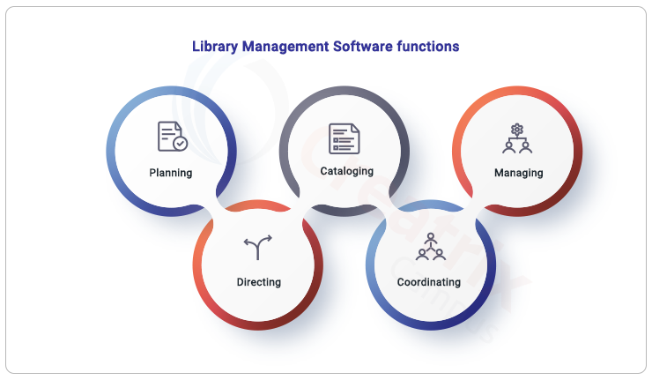
Login Module

Student Module

Admin Module

SOFTWARE INSTALLATION

Windows:
Download PostgreSQL:
Visit the official PostgreSQL download page: https://www.postgresql.org/download/windows/
Choose the version suitable for your system (32-bit or 64-bit) and download the installer.

Run the Installer:
Locate the downloaded installer and double-click on it to run the installation.
Installation Wizard:
The installation wizard will guide you through the process. Click "Next" to proceed.
Select Components:
Choose the components you want to install. The default settings are usually fine for most users. Click "Next" to continue.
Select Installation Directory:
Choose the directory where you want to install PostgreSQL. The default is usually fine unless you have a specific reason to change it. Click "Next."
Enter Data Directory:

Choose the data directory where PostgreSQL will store its data. The default is usually fine. Click "Next."
Enter Password:
Set a password for the PostgreSQL superuser (postgres). Remember this password as you'll need it later. Click "Next."
Port Configuration:
Choose the port PostgreSQL will use. The default is 5432. Click "Next."

Locale:
Choose the default locale used by the database. The default is usually fine. Click "Next."
Initialize Database Cluster:
Click "Next" to initialize the database cluster.
Enter Additional Parameters:
If you have additional parameters, enter them here. Otherwise, click "Next."
Installation Progress:
The installer will now install PostgreSQL. Once complete, click "Next."
Stack Builder (Optional):
You can use Stack Builder to install additional tools and drivers. You can skip this step if you don't need it. Click "Next."
Complete the Installation:
Click "Finish" to complete the installation.
Add PostgreSQL to the System Path (Optional):
This step is optional but recommended. It allows you to run PostgreSQL commands from any command prompt.
Find the installation directory (default is C:\Program Files\PostgreSQL[version]\bin).
Add this directory to your system's PATH environment variable.
Start PostgreSQL:
You can start PostgreSQL by using the Services application (services.msc) or by running the following command in the command prompt:
net start postgresql-[version]
Replace [version] with your PostgreSQL version number.
That's it! PostgreSQL should now be installed and running on your Windows system. You can access it using the command line or by using tools like pgAdmin.

For Ubuntu/Debian-based Systems:
Assuming you are using a package manager like apt or yum.
Update Package List: sudo apt update
Install PostgreSQL: sudo apt install postgresql postgresql-contrib
Start PostgreSQL Service: sudo service postgresql start
or
sudo systemctl start postgresql
Enable PostgreSQL Service on Boot: sudo systemctl enable postgresql
Switch to the PostgreSQL User: sudo -i -u postgres
Access PostgreSQL Shell: psql
You should now be in the PostgreSQL interactive shell.
Set a Password for the PostgreSQL User (if needed): \password postgres
Follow the prompts to set a password for the 'postgres' user.
Exit PostgreSQL Shell: \q
Then exit the PostgreSQL user's shell: exit
For CentOS/RHEL-based Systems:
Enable PostgreSQL Repository: sudo yum install https://download.postgresql.org/pub/repos/yum/reporpms/EL-7-x86_64/pgdg-redhat-repo-latest.noarch.rpm
Install PostgreSQL: sudo yum install postgresql12-server postgresql12-contrib
Initialize Database: sudo /usr/pgsql-12/bin/postgresql-12-setup initdb
Start PostgreSQL Service: sudo systemctl start postgresql-12
Enable PostgreSQL Service on Boot: sudo systemctl enable postgresql-12
Switch to the PostgreSQL User: sudo -i -u postgres
Access PostgreSQL Shell: psql
You should now be in the PostgreSQL interactive shell.
Set a Password for the PostgreSQL User (if needed): \password postgres
Follow the prompts to set a password for the 'postgres' user.
Exit PostgreSQL Shell: \q
Then exit the PostgreSQL user's shell: exit
These steps provide a basic setup of PostgreSQL. Depending on your needs, you might need to configure additional settings, create databases, and manage roles and permissions. Make sure to refer to the PostgreSQL documentation for more detailed information: PostgreSQL Documentation.
CODING:
Coding may refer to:
- Channel coding, in coding theory
- Line coding
- Computer programming, the process of designing, writing, testing, debugging / troubleshooting, and maintaining the source code of computer programs.
- The process of Statistical classification of information.
- Coding (social sciences), refers to an analytical process in which data, in both quantitative form (such as questionnaires results) or qualitative (such as interview transcripts) are categorised to facilitate analysis.
- Coding (therapy), a controversial therapy used to treat addictions.
- Legal coding, the process of creating summary or keyword data from a document. It is widely used in the legal profession to create a fast-search index or database of documents for use in litigation.
- A coding strand of DNA is translated into a protein product.
- Code Blue (emergency code), which is a patient in Cardiac Arrest or Respiratory Arrest.
The basic coding related to my project are as follows:
Summary About Coding Part
- Login Page
- Admin
- User
- Register Page
- User
- Total Books Page
- Admin
- User
- Student Books Page
- User
- Issued Books Page
- Admin
User Register:
import { useState } from 'react';
import logo from '../../assets/logo.png'
import React from 'react'
import { useNavigate } from 'react-router-dom';
import { FaEye, FaEyeSlash } from 'react-icons/fa';
import axios from 'axios';

function SignUp() {
const [passwordVisible, setPasswordVisible] = useState(false);
const [confirmVisible, setconfirmVisible] = useState(false);

const [data, setData] = useState({
rollno: "",
name: "",
email: "",
password: "",
gender: "",
phonenumber: "",
department: "",
confirmpassword: ""
})

const { name, phonenumber, email, department, gender, password, confirmpassword, rollno } = data
const navigate = useNavigate();

const ChangeHandler = (e) => {
setData({ ...data, [e.target.name]: e.target.value })
}

const SubmitHandler = async (e) => {
e.preventDefault()

if (password.length <= 8 && password.length >= 12) {
alert('please enter strong password')
}
else if (password !== confirmpassword) {
alert('password does not matched')
}

else {
try {
const response = await axios.post('http://localhost:3008/register', data);
if (response.data.message === 'Username already exists') {
alert('User already exist');
}
else {
alert('Register Successfull');
navigate('/signin');

}
}
catch (error) {
console.error("An error occurred:", error);
}
}
}

const LinkClickHandler = () => {
navigate('/signin')
}
return (
<>

<p id='library'>Library</p>
<div>
<div>
<img src={logo} className='logo' />
</div>
<div className='card'>
<form onSubmit={SubmitHandler}>
<p id='head'>Sign Up</p>
<div className='form-data'>
<div>
<label>Name</label><br />
<input type="text" name='name' value={name} onChange={ChangeHandler} required />
<br /><br />
<label>Phonenumber</label><br />
<input type="text" name='phonenumber' value={phonenumber} onChange={ChangeHandler} required />
<br /><br />
<label>Gender</label><br />
<select name='gender' value={gender} onChange={ChangeHandler} required>
<option value=" "></option>
<option value="male">Male</option>
<option value="female">Female</option>
</select>

<br /><br />
<label>Password</label><br />
<input
type={passwordVisible ? "text" : "password"} name='password' value={password} onChange={ChangeHandler} required />
<span
className="password-toggle1"
onClick={() => setPasswordVisible(!passwordVisible)}>
{passwordVisible ? <FaEyeSlash /> : <FaEye />}
</span>
</div>
<div>
<label>Rollno</label><br />
<input type="text" name='rollno' value={rollno} onChange={ChangeHandler} required />
<br /><br />
<label>Email</label><br />
<input type="text" name='email' value={email} onChange={ChangeHandler} required />
<br /><br />
<label>Department</label><br />
<select name='department' value={department} onChange={ChangeHandler} required>
<option value=" "> </option>
<option>CME</option>
<option>ECE</option>
<option>EEE</option>
<option>MECHANICAL</option>
<option>ARCH</option>
<option>CIVIL</option>
<option>AUTOMOBILE</option>
</select>
<br /><br />
<label>ConfirmPassword</label><br />
<input
type={confirmVisible ? "text" : "password"}
id="password" name='confirmpassword' value={confirmpassword} onChange={ChangeHandler} required />
<span
className="password-toggle2"
onClick={() => setconfirmVisible(!confirmVisible)}>
{confirmVisible ? <FaEyeSlash /> : <FaEye />}
</span>
</div>
</div>
<br />
<center>
<input type="submit" className='submit' value="SignUp" />
</center>
</form>
<br />
<h6>Already have an Account ? <a href='#' onClick={LinkClickHandler}>Login</a></h6>
</div>
</div>

</>
)
}

export default SignUp

CSS Page

*{
margin: 0;
padding: 0;
font-family: Arial, Helvetica, sans-serif;
}

body {
background-image: url('./assets/Collegebackground.jpg');
background-repeat: no-repeat;
background-size:cover;
background-attachment: fixed;
height: 100vh;
width: 100%;
padding-top: 10px;
position: static;
}

.logo {
position: absolute;
left: 1%;
top: 5%;
width:10%;
filter: brightness(85%);
}

#library {
position: absolute;
font-size: 35px;
top: 10%;
left: 64%;
font-family:Helvetica;
font-weight:600;
color: white;
}

.card {
background-color: white;
border: 2px solid #f1f1f1;
border-radius: 10px;
margin-left: 53%;
margin-top: 10%;
z-index: 2;
width: fit-content;
height: fit-content;
padding-left: 20px;
padding-top: 10px;
padding-bottom: 10px;
}

#head {
text-align: center;
font-size: 25px;
}

.form-data {
display: flex;
}

label,
select {
color: rgb(87, 87, 87);
font-size: 15px;
}

.submit {
background-color: coral;
color: white;
border: none;
border-radius: 3px;
padding: 3px 10px 3px 10px;
}

.form-data input,
select {
width: 90%;
height: 9%;
}

.card h6 {
text-align: center;
}

.card a {
color: coral;
text-decoration: none;
}

.password-toggle1 {
position: absolute;
top: 71%;
right: 54%;
transform: translateY(-50%);
}

.password-toggle2 {
position: absolute;
top: 71%;
right: 6%;
transform: translateY(-50%);
}

LOGIN Page
User Login:
import { useState } from 'react';
import logo from '../../assets/logo.png'
import React from 'react'
import { useNavigate } from 'react-router-dom';
import { FaEye, FaEyeSlash } from 'react-icons/fa';
import axios from 'axios';

function SignIn() {

const [passwordVisible, setPasswordVisible] = useState(false);
const [data, setData] = useState({
email: "",
password: ""
})
const { email, password } = data;

const navigate = useNavigate();

const ChangeHandler = (e) => {
setData({ ...data, [e.target.name]: e.target.value })

}
const SubmitHandler = async (e) => {

e.preventDefault();
try {
const response = await axios.post('http://localhost:3008/login', data);

if (response.data.message === 'User not found') {
alert('user not Found')
}
else if (response.data.message === 'Incorrect password') {
alert('Incorrect Password')
}
else if (response.data.message === 'Login successful') {

const studentid = response.data.user.rollno;
sessionStorage.setItem('studentdata', studentid);
alert('Login Successfull');
navigate('/studentbooks');

}
else {
console.error('Login failed:', response.data.message);
}
}
catch (error) {
console.error('An error occurred:', error);
}

}

const LinkClickHandler = () => {
navigate('/signup')
}
const radiobtnHandler = () =>{
navigate('/login')
}
return (
<>

<p id='library'>Library</p>
<div>
<img src={logo} className='logo' alt='img' />
</div>
<div className='card-login'>
<form onSubmit={SubmitHandler}>
<p id='head'>Login</p>
<div className='radiobtns'>
<label>Admin</label>
<input type="radio" onClick={radiobtnHandler}/>&emsp;
<label>User</label>
<input type="radio" checked />
</div>
<div className='form-data-login'>
<div>
<label>Email</label><br />
<input type="text" name='email' value={email} onChange={ChangeHandler} required />
<br /><br />
</div>
<div>
<label>Password</label><br />
<div id='pass-div'>
<input
type={passwordVisible ? "text" : "password"}
id="password" name='password' value={password} onChange={ChangeHandler} required />
<span
className="password1-toggle"
onClick={() => setPasswordVisible(!passwordVisible)}>
{passwordVisible ? <FaEyeSlash /> : <FaEye />}
</span>
</div>
<p className='forgot'><a href='/forgotpassword'>Forgot password ?</a></p>
</div>
</div>
<center>
<input type="submit" className='submit' value="Login" />
</center>
</form>
<br />
<h6>You don't have an Account ? <a href='#' id='Signup-link' onClick={LinkClickHandler}>SignUp</a></h6>
</div>

</>
)

}

export default SignIn

user login CSS:
.card-login {
background-color: white;
border: 2px solid #f1f1f1;
border-radius: 10px;
margin-left: 56%;
margin-top: 15%;
z-index: 2;
width: 25%;
height: fit-content;
padding: 20px;

}

.form-data-login input {
width: 100%;
height: 9%;
}

.card-login h6 {
text-align: center;
}

#pass-div {
display: flex;
border: 1px solid grey;
border-radius: 2px;
height: fit-content;
}

#pass-div input {
border: none;
height: auto;
}

.card-login a {
color: coral;
text-decoration: none;
}

.forgot {
text-align: right;
padding-top: 10px;
font-size: 15px;
}

.formdata{
text-align: center;
}
.formdata input{
width: 90%;
margin:8% 0 5% 0 ;
}
.formdata button{
background-color: coral;
color: white;
border: 1px solid coral;
padding: 1% 3% 1% 3%;
border-radius: 5px;
margin-top: 5%;
}

Admin Login:
import { useState } from 'react';
import logo from '../../assets/logo.png'
import React from 'react'
import { useNavigate } from 'react-router-dom';
import { FaEye, FaEyeSlash } from 'react-icons/fa';

function Login() {

const [passwordVisible, setPasswordVisible] = useState(false);
const [data, setData] = useState({
email: "",
password: ""
})

const navigate = useNavigate();

const { email, password } = data;

const ChangeHandler = (e) => {
setData({ ...data, [e.target.name]: e.target.value });
}
const SubmitHandler = async (e) => {
e.preventDefault();

try {
const response = await axios.post('http://localhost:3008/adminlogin',data)
if(response.data.message === 'Admin Login successful'){
alert('Admin Login successful')
navigate('/totalbooks')
}
else if(response.data.message === 'Unauthorized Admin Credentials.!'){
alert("Unauthorized Admin Credentials.!")
}
else{
console.error("error");
}
}
catch (error) {
console.error("error");
}

}

const radiobtnHandler = () =>{
navigate('/signin')
}
return (
<>

<p id='library'>Library</p>
<div>
<img src={logo} className='logo' alt='img' />
</div>
<div className='card-login'>
<form onSubmit={SubmitHandler}>
<p id='head'>Login</p>
<div className='radiobtns'>
<label>Admin</label>
<input type="radio" checked/>&emsp;
<label>User</label>
<input type="radio" onClick={radiobtnHandler} />
</div>
<div className='form-data-login'>

<div>
<label>Email</label><br />
<input type="text" name='email' value={email} onChange={ChangeHandler} required />
<br />
</div>
<br />
<div>
<label>Password</label><br />
<div id='pass-div'>
<input
type={passwordVisible ? "text" : "password"}
id="password" name='password' value={password} onChange={ChangeHandler} required />
<span
className="password2-toggle"
onClick={() => setPasswordVisible(!passwordVisible)}>
{passwordVisible ? <FaEyeSlash /> : <FaEye />}
</span>
</div>
</div>
</div><br />
<center>
<input type="submit" className='submit' value="Login" />
</center>
</form><br />
</div>

</>
)
}

export default Login

admin login CSS:
.card-login {
background-color: white;
border: 2px solid #f1f1f1;
border-radius: 10px;
margin-left: 56%;
margin-top: 15%;
z-index: 2;
width: 25%;
height: fit-content;
padding: 20px;

}
.form-data-login input {
width: 100%;
height: 9%;
}

.card-login h6 {
text-align: center;
}

#pass-div {
display: flex;
border: 1px solid grey;
border-radius: 2px;
height: fit-content;
}

#pass-div input {
border: none;
height: auto;
}
.card-login a {
color: coral;
text-decoration: none;
}

.forgot {
text-align: right;
padding-top: 10px;
font-size: 15px;
}

Main Page:
import React from 'react'
import logo from '../assets/logo.png'
import ImageScroll from './ImageScroll';
import sbtet from '../assets/sbtet.png'
import { Container } from 'react-bootstrap';
import { FaFacebook, FaLinkedin, FaTwitter } from 'react-icons/fa'
import { useRef } from 'react';
import aptvideo from '../media/aptvideo.mp4'

function Main() {
const contactSectionRef = useRef(null);

const scrollToContact = () => {
if (contactSectionRef.current) {
contactSectionRef.current.scrollIntoView({ behavior: 'smooth' });
}
};

return (
<>
<Container>
<div className='mainpage'>
<header>
<a href="/signin" id='links'>Login <svg xmlns="http://www.w3.org/2000/svg" width="25" height="25" fill="currentColor" class="bi bi-person-fill-lock" viewBox="0 0 16 16">
<path d="M11 5a3 3 0 1 1-6 0 3 3 0 0 1 6 0Zm-9 8c0 1 1 1 1 1h5v-1a1.9 1.9 0 0 1 .01-.2 4.49 4.49 0 0 1 1.534-3.693C9.077 9.038 8.564 9 8 9c-5 0-6 3-6 4Zm7 0a1 1 0 0 1 1-1v-1a2 2 0 1 1 4 0v1a1 1 0 0 1 1 1v2a1 1 0 0 1-1 1h-4a1 1 0 0 1-1-1v-2Zm3-3a1 1 0 0 0-1 1v1h2v-1a1 1 0 0 0-1-1Z" />
</svg></a>
<a href="#contact-section" id='links' onClick={scrollToContact}>Contact <svg xmlns="http://www.w3.org/2000/svg" width="16" height="16" fill="currentColor" class="bi bi-telephone-fill" viewBox="0 0 16 16">
<path fill-rule="evenodd" d="M1.885.511a1.745 1.745 0 0 1 2.61.163L6.29 2.98c.329.423.445.974.315 1.494l-.547 2.19a.678.678 0 0 0 .178.643l2.457 2.457a.678.678 0 0 0 .644.178l2.189-.547a1.745 1.745 0 0 1 1.494.315l2.306 1.794c.829.645.905 1.87.163 2.611l-1.034 1.034c-.74.74-1.846 1.065-2.877.702a18.634 18.634 0 0 1-7.01-4.42 18.634 18.634 0 0 1-4.42-7.009c-.362-1.03-.037-2.137.703-2.877L1.885.511z" />
</svg></a>
</header>
<div className='mainpage-div'>
<img className="img" src={logo} alt='img' />
<p><span className='span'><h1>ANDHRA POLYTECHNIC KAKINADA</h1>&emsp;<h6>Estb:1946</h6></span>
<h5>Jagannaickpur,Kakinada,533002,PH:0884-2376192,AndhraPradesh</h5>
<img src={sbtet} alt="image" /></p>

</div>
<ImageScroll />
<br />
<div className='about-divs'>
<div className='about-library col-5'>
<h4>DEPARTMENT OF TECHNICAL EDUCATION <br /> ANDHRA POLYTECHNIC : KAKINADA LIBRARY RULES</h4><br />
<ol>
<li>EVERY PERSON WHO ENTERS THE LIBRARY HAS TO SIGN THE VISITORS REGISTER.</li><br />
<li>EVERY PERSON WHO WANT TO MEMBESHIP IN LIIBRARY HAS TO REGISTER FIRST.</li><br />
<li>BAGS, SNATCHES, PERSONAL BOOKS etc ARE NOT ALLOWED INTO THE LIBRARY.</li><br />
<li>REQUESTED TO MAINTAIN SILENCE IN THE LIBRARY.</li><br />
<li>MEMBERS ARE RESPONSIBLE FOR ANY DAMAGE CAUSED BY THEM.</li><br />
<li>THE LIBRARIAN RESERVES THE RIGHT TO SUSPEND THE MEMBERSHIP OF ANY MEMBER FOUND MISBEHAVING.</li><br />
<li>FOR BOOKS RETURNED LATE,A PENALTY OF Rs.1 PER DAY IS CHARGED.</li><br />
<li>IN CASE OF BOOKS LOST THE BORROWER IS REQUIRED TO REPLACE THE BOOKS.</li><br />
<li>NO-DUES CERTIFICATE WILL BE ISSUED AT THE TIME OF LEAVING THE COLLEGE.</li>
</ol>
</div>
<h1 className='vertical-text'>ANDHRA POLYTECHNIC KAKINADA</h1>
<div className='col-5'>
<div className='about-library col-12' >
<h4>DEPARTMENT OF TECHNICAL EDUCATION <br /> ANDHRA POLYTECHNIC : KAKINADA</h4><br />
<ol>
<h5>AVAILABLE BOOKS:</h5>
<li>DEPARTMENT BOOKS FOR ALL BRANCHES</li><br />
<li>GENERAL SUBJECTS BOOKS:PHYSICS, MATHS ,CHEMISTRY</li><br />
<li>GENERAL FICTION,NON-FICTION BOOKS</li><br />
<li>UPSC,ECET,GATE PREPERATION BOOKS</li><br />
<li>NEWS PAPERS AND MAGAZINES</li><br />
<li>PREVIOUS YEARS QUESTION PAPERS</li>
</ol>
</div><br />
<div className='about-library col-12'>
<h4>DEPARTMENT OF TECHNICAL EDUCATION <br /> ANDHRA POLYTECHNIC : KAKINADA</h4><br />
<ol>
<h5>TIMINGS:</h5>
<h6>9:30 AM to 6:00 PM</h6>
<h6>🔘DIGITAL LIBRARY AVAILABLE</h6>
</ol>
</div>
</div>
</div><br />
</div><br />
<div className='d-flex map_vedio_div'>
<div className=' col-6'>
<iframe src="https://www.google.com/maps/embed?pb=!1m18!1m12!1m3!1d3816.898446587281!2d82.23037121486999!3d16.930300888354044!2m3!1f0!2f0!3f0!3m2!1i1024!2i768!4f13.1!3m3!1m2!1s0x3a3827eb32268f59%3A0xf1eaf501d757f10e!2sAndhra+Polytechnic!5e0!3m2!1sen!2sin!4v1528653188337" width="95%" height="98%" referrerpolicy="no-referrer-when-downgrade"></iframe>
</div>
<div className='col-6'>
<video controls autoPlay>
<source src={aptvideo} type="video/mp4" />
</video>
</div>
</div><br />
</Container>

<footer ref={contactSectionRef}>
<p>©2023 <a href="/">Andhra Polytechnic Kakinada.</a> All rights reserved.</p>
<div className='contact-details'>
<h3>PH:0884-2376192</h3>
<a href="https://www.facebook.com/andhrapolytechnic/" ><FaFacebook className='icon' /></a>
<a href="https://twitter.com/i/flow/login?redirect_after_login=%2Fapt_aptosa"><FaTwitter className='icon' /></a>
<a href="https://www.linkedin.com/company/aptcollege-kakinada"><FaLinkedin className='icon' /></a>
</div>
</footer>
</>
)
}

export default Main;

main page CSS:

.mainpage{
height:max-content;
}

.mainpage-div {
position: relative;
height: 100%;
width: 100%;
text-align: center;
padding: 20px;
display: flex;
flex-direction: column;
align-items: center;
}

.mainpage::before {
content: "";
position: absolute;
top: 0;
left: 0;
width: 100%;
height:240%;
background-image: url('./assets/bg.jpg');
background-repeat: no-repeat;
background-size: cover;
filter: brightness(55%);
z-index: -1;
}

.mainpage-div h1 {
color: white;
font-weight: bold;
margin-top: 10px;
text-shadow: 2px 2px 4px rgb(132, 132, 132);
}
.span{
color: white;
display: flex;
}
.mainpage-div h5 {
font-weight: bold;
color: rgb(240, 240, 240);
}
.mainpage-div h6{
margin-top: 4%;
color: white;
font-weight: bold;
}
.img {
max-width:8%;
height: auto;
}
#links{
font-size: medium;
float: right;
text-decoration: none;
color:rgb(183, 182, 182);
padding-right:3%;
padding-top:1%;
font-weight: bold;
}
#links:hover{
color: rgb(255, 255, 255);
}

.contact-head-div h1{
font-weight: bold;
padding-top: 1%;
}
.img-logo{
height: 5%;
width:5%;
}
.map{
border: 5px solid rgb(94, 94, 94);
border-radius: 15px;
height:60vh;
width:100%;
}
video{
border: #000;
border-radius: 3%;
height: 100%;
width: 100%;
}

.contact-details{
padding-top: 3%;
color: white;
}
.contact-details a{
color: white;
padding:2%;
}
.contact-details a:hover{
color:rgb(0, 34, 255);
}
.contact-details h3:hover{
color:rgb(0, 34, 255);
}
.icon{
height: 2%;
width: 2%;
}

.logos{
overflow: hidden;
padding: 1%;
background: linear-gradient(80deg, #aaaaaa, #ffffff70);
white-space: nowrap;
position: relative;
height: 34vh;
z-index: 1;
border-radius: 15px;
}
.logos::before,
.logos::after{
position: absolute;
top: 0;
width: 270px;
height: 100%;
content: "";
z-index: 2;
left: 0;
right: 0;
}
.logos::before{
left: 0;
}
.logos::after{
right:0;
}

.logos-slide {
overflow: hidden;
display: inline-block;
animation: slide 50s linear infinite;
}
.logos-slide img{
margin: -3px 15px;
object-fit: cover;
}
.slide_image {
background-color: #ffff;
border-radius: 7px;
height:200px;
width: 255px;
margin: -3px 15px;
object-fit: cover;
}

.logos:hover .logos-slide{
animation-play-state: paused;
}

.about-divs{
display: flex;
justify-content: space-between;
}
.about-library{
background: linear-gradient(84deg, rgb(247 0 0 / 92%), rgb(176, 176, 176));
background-size: contain;
width: 48%;
height: fit-content;
padding: 2%;
border: none;
border-radius: 15px;
}
.about-library h4{
text-shadow:
-1px -1px 0 #ffffff,
2px -1px 0 #ffffff,
-1px 2px 0 #ffffff,
2px 2px 0 #ffffff;
color: rgb(5, 5, 180);
font-weight: 600;
text-align: center;
}
.about-library ol{
color: white;
text-align: justify;
}
.vertical-text {
writing-mode: vertical-rl;
text-orientation: upright;
white-space: nowrap;
font-weight: bold;
color: #c44a12;
padding-top:5%;
font-size: 25px;
font-weight:700;
text-shadow:
-2px -2px 0 rgb(255, 255, 255),
2px -2px 0 rgb(255, 255, 255),
-2px 2px 0 rgb(255, 255, 255),
2px 2px 0 rgb(255, 255, 255) ;
}
ol h5{
color:rgb(67, 2, 2);
font-weight: bold;
}
footer{
background-color: rgb(8, 8, 78);
height: 40vh;
text-align: center;
padding-top: 2%;
color: white;
}
footer a{
text-decoration: none;
color: rgb(188, 188, 188);
}
footer a:hover{
color: blue;
}

@keyframes slide {
from {
transform: translateX(0);
}
to {
transform: translateX(-100%);
}
}
@media (max-width: 768px) {
.mainpage-div {
padding: 10px;
}

h1 {
font-size: 24px;
margin-top: 10px;
h5 {
font-size: 16px;
}

img {
max-width: 50%;
}
}

Header part:
import React from 'react'

function Header() {
return (
<>
<div className='header'>
<h2 className='library'>Library</h2>
<div className='student-div'>
<h6>Student</h6>
<div className='user-logo'>
<a href="#" ><svg xmlns="http://www.w3.org/2000/svg" width="40" height="40" fill="white" class="bi bi-person-circle" viewBox="0 0 16 16">
<path d="M11 6a3 3 0 1 1-6 0 3 3 0 0 1 6 0z" />
<path fill-rule="evenodd" d="M0 8a8 8 0 1 1 16 0A8 8 0 0 1 0 8zm8-7a7 7 0 0 0-5.468 11.37C3.242 11.226 4.805 10 8 10s4.757 1.225 5.468 2.37A7 7 0 0 0 8 1z" />
</svg></a>
</div>
</div>

</div>
</>
)
}

export default Header

header part CSS:
.header {
display: flex;
padding-top: 1%;
justify-content: space-between;

}
.user-logo {
padding-left: 15px;
padding-top: 5px;
}

Forgot Password:
import React, { useState, useRef } from 'react';
import axios from 'axios';
import logo from '../assets/logo.png';
import { useNavigate } from 'react-router-dom';

function OTPComponent() {

const [otp, setOTP] = useState(['', '', '', '']);
const [sentOTP, setSentOTP] = useState(false);
const [validated, setValidated] = useState(false);
const otpInputRefs = [useRef(null), useRef(null), useRef(null), useRef(null)]; //
const [userEmail, setUserEmail] = useState('');
const [newpassword, setNewPassword] = useState('');
const [confirmnewPassword, setConfirmnewPassword] = useState('');

const handleSendOTP = async () => {
try {
if (userEmail === "") {
return alert('please enter email id')
}
const response = await axios.post('http://localhost:3008/send-otp', {
email: userEmail,
});
console.log(response.data);
if (response.data.message === 'OTP sent successfully')
sessionStorage.setItem('useremail', userEmail);
alert('OTP sent successfully')
setSentOTP(true);
} catch (error) {
console.log(error)
}
};

const handleValidateOTP = async () => {
if (sentOTP) {
try {
const enteredOTP = otp.join('');
const response = await axios.post('http://localhost:3008/validationotp', {
otp: enteredOTP,
});

if (response.data.message === 'Otp validation Successfull') {
alert('OTP validated successfully');
setValidated(true);
}
else {
if(response.data.message === 'Please Enter valid otp')
return alert('Please Enter valid otp');
}
} catch (error) {
console.error('Invalid OTP or failed to validate OTP', error);
}
} else {

alert('Please send OTP first.')
}
};

const handleOTPDigitChange = (index, value) => {
const newOTP = [...otp];
newOTP[index] = value;
setOTP(newOTP);

if (index < otpInputRefs.length - 1) {
otpInputRefs[index + 1].current.focus();
}
};

const navigate = useNavigate();

const handlesetpassword = async () => {
if (validated) {
try {
if (!newpassword || newpassword === "" || confirmnewPassword === "") {
return alert("Please Enter your password");
}
const email = sessionStorage.getItem('useremail');
setUserEmail(email);
const response = await axios.put('http://localhost:3008/settingnewpassword', {
email: userEmail,
newpassword: newpassword
});

if (response.data.message === 'Password updated successfully') {
alert("Password updated successfully");
navigate('/signin')
} else {
alert('Password update failed');
}
} catch (error) {
console.log(error);
}
}
};

return (
<>
<div>
<img src={logo} className='logo' alt='img' />
</div>
<div className='card-login'>
<div className='formdata'>
<h3>Forgot Password</h3>

{sentOTP && !validated ? (
<div>
<p>We will send an OTP to your email to reset your password.</p>
<div className="otp-input">
{otp.map((digit, index) => (
<input
key={index}
type="text"
placeholder="0"
required
value={digit}
onChange={(e) => handleOTPDigitChange(index, e.target.value)}
ref={otpInputRefs[index]}
/>
))}
</div>
<button onClick={handleValidateOTP}>Validate OTP</button>
</div>
) : (
validated ? (
<>
<p>Please enter your new password:</p>
<input
type="password"
value={newpassword}
placeholder="New Password"
required
onChange={(e) => setNewPassword(e.target.value)}
/>
<br />
<input
type="password"
value={confirmnewPassword}
placeholder="Confirm Password"
required
onChange={(e) => setConfirmnewPassword(e.target.value)}
/>
<br />
<button onClick={handlesetpassword}>Set Password</button>
</>
) : (
<>
<p>We will send an OTP to your email to reset your password.</p>
<input
type="text"
placeholder="User Email"
required
value={userEmail}
onChange={(e) => setUserEmail(e.target.value)}
/>
<br />
<button onClick={handleSendOTP}>Send OTP</button>
</>
)
)}
</div>
</div>
</>
);
}

export default OTPComponent;

forgot password CSS:

.otp-input{
display: flex;
text-align: center;
margin-left: 8%;
}
.otp-input input{
width: 80%;
height: 5vh;
text-align: center;
margin-right: 10%;
border: 1px solid grey;
border-radius: 5px;
}

Image Scroll :
import React from 'react'
import img1 from '../assets/img1.jpg'
import img2 from '../assets/img2.jpeg'
import img3 from '../assets/im3.jpg'
import img4 from '../assets/img4.jpeg'
import img5 from '../assets/img5.jpg'

import { Container } from 'react-bootstrap'
function ImageScroll() {
return (
<>
<Container>
<div className='logos'>

<div className='logos-slide'>
<img src={img1} alt="image1" className='slide_image' width={"105"}/>
<img src={img2} alt="image2" className='slide_image' width={"105"}/>
<img src={img3} alt="image3" className='slide_image' width={"105"}/>
<img src={img4} alt="image4" className='slide_image' width={"105"}/>
<img src={img5} alt="image5" className='slide_image' width={"105"}/>
<img src={img1} alt="image1" className='slide_image' width={"105"}/>
<img src={img2} alt="image2" className='slide_image' width={"105"}/>
<img src={img3} alt="image3" className='slide_image' width={"105"}/>
<img src={img4} alt="image4" className='slide_image' width={"105"}/>
<img src={img5} alt="image5" className='slide_image' width={"105"}/>

</div>
<div className='logos-slide'>
<img src={img1} alt="image1" className='slide_image' width={"105"}/>
<img src={img2} alt="image2" className='slide_image' width={"105"}/>
<img src={img3} alt="image3" className='slide_image' width={"105"}/>
<img src={img4} alt="image4" className='slide_image' width={"105"}/>
<img src={img5} alt="image5" className='slide_image' width={"105"}/>
<img src={img1} alt="image1" className='slide_image' width={"105"}/>
<img src={img2} alt="image2" className='slide_image' width={"105"}/>
<img src={img3} alt="image3" className='slide_image' width={"105"}/>
<img src={img4} alt="image4" className='slide_image' width={"105"}/>
<img src={img5} alt="image5" className='slide_image' width={"105"}/>

</div>

</div>
</Container>
</>
)
}

export default ImageScroll

image scroll CSS:

.logos{
overflow: hidden;
padding: 1%;
background: linear-gradient(80deg, #aaaaaa, #ffffff70);
white-space: nowrap;
position: relative;
height: 34vh;
z-index: 1;
border-radius: 15px;
}
.logos::before,
.logos::after{
position: absolute;
top: 0;
width: 270px;
height: 100%;
content: "";
z-index: 2;
left: 0;
right: 0;
}
.logos::before{
left: 0;
}
.logos::after{
right:0;
}

.logos-slide {
overflow: hidden;
display: inline-block;
animation: slide 50s linear infinite;
}
.logos-slide img{
margin: -3px 15px;
object-fit: cover;
}
.slide_image {
background-color: #ffff;
border-radius: 7px;
height:200px;
width: 255px;
margin: -3px 15px;
object-fit: cover;
}

.logos:hover .logos-slide{
animation-play-state: paused;
}

Paginations:
import React from 'react';
import { Pagination } from 'react-bootstrap';

function Paginations({ currentPage, totalPages, onPageChange }) {
const paginationItems = [];

for (let page = 1; page <= totalPages; page++) {
paginationItems.push(
<Pagination.Item
key={page}
active={page === currentPage}
onClick={() => onPageChange(page)}
>
{page}
</Pagination.Item>
);
}

return (
<Pagination className='pagination pagination-sm'>
{paginationItems}
<Pagination.Last/>
</Pagination>
);
}

export default Paginations;

pagination CSS:
.pagination {
justify-content: center;
}

All Books page:
import React, { useState, useEffect } from 'react';
import { useNavigate } from 'react-router-dom';
import { FaSearch } from 'react-icons/fa';
import Container from 'react-bootstrap/Container';
import Header from '../Header';
import Table from 'react-bootstrap/Table';
import axios from 'axios';
import Paginations from '../paginations';

function AllBooks() {
const [currentPage, setCurrentPage] = useState(1);
const itemsPerPage = 10;
const customTableStyle = {
border: '1px solid black',
};

const [data, setData] = useState([]);
const [searchQuery, setSearchQuery] = useState('');
const [selectedDepartment, setSelectedDepartment] = useState('AllDepartments');

useEffect(() => {
try {
axios.get('http://localhost:3008/allbooks').then((response) => {
setData(response.data);
});
} catch (error) {
console.log(error);
}
}, []);

const navigate = useNavigate();

const ClickedHandler = () => {
navigate('/studentbooks');
};

const handleSearch = (e) => {
setSearchQuery(e.target.value);
};

const handleDepartmentChange = (e) => {
setSelectedDepartment(e.target.value);
};

const filteredData = data.filter((item) => {
const searchTerm = searchQuery.toLowerCase();
const department = selectedDepartment.toLowerCase();
return (
(department === 'alldepartments' || item.department.toLowerCase() === department) &&
(item.book_name.toLowerCase().includes(searchTerm) ||
item.author_name.toLowerCase().includes(searchTerm))
);
});

const startIndex = (currentPage - 1) * itemsPerPage;
const endIndex = startIndex + itemsPerPage;
const itemsToDisplay = filteredData.slice(startIndex, endIndex);

const totalPages = Math.ceil(filteredData.length / itemsPerPage);

const handlePageChange = (page) => {
setCurrentPage(page);
};

return (
<Container>
<Header />
<div className="header">
<div className="button-group">
<button onClick={ClickedHandler} className="whitebtn">
My books
</button>
<button className="orangebtn">Books</button>
</div>
<div className="dept-search-div">
<select className='dept' value={selectedDepartment} onChange={handleDepartmentChange}>
<option value="AllDepartments">All Departments</option>
<option value="general">General</option>
<option value="CME">CME</option>
<option value="ECE">ECE</option>
<option value="EEE">EEE</option>
<option value="CIVIL">CIVIL</option>
<option value="MECHANICAL">MECHANICAL</option>
<option value="ARCHITECTURE">ARCHITECTURE</option>
<option value="AUTOMOBILE">AUTOMOBILE</option>
</select>
<div className="search">
<input
type="text"
placeholder="Search"
value={searchQuery}
onChange={handleSearch}
/>
<FaSearch className="search-icon" />
</div>
</div>
</div>
<br />
<Table bordered hover style={customTableStyle}>
<thead>
<tr>
<th>S.No</th>
<th>Book ID</th>
<th>Status</th>
<th>Author</th>
<th>Book name</th>
<th>Publisher</th>
<th>Model</th>
<th>Price</th>
<td>penalty</td>
<th>Issuable/Reserved</th>
</tr>
</thead>
<tbody>
{itemsToDisplay.map((item, index) => (
<tr key={index}>
<td>{startIndex + index + 1}</td>
<td>{item.book_id}</td>
<td>{item.count === 0 ? <p style={{ color: 'red' }}>InActive</p> : <p style={{ color: 'green' }}>Active</p>}</td>
<td>{item.author_name}</td>
<td>{item.book_name}</td>
<td>{item.publisher}</td>
<td>{item.model}</td>
<td>{item.penalty}</td>
<td>{item.price}</td>
<td>{item.status}</td>
</tr>
))}
</tbody>
</Table>
<Paginations
currentPage={currentPage}
totalPages={totalPages}
onPageChange={handlePageChange}
/>
</Container>
);
}

export default AllBooks;

all books page CSS:

Table {
width: 100%;
}

tbody tr {
border: none;
}

Table,
th,
td {
background-color: white;
text-align: center;
padding: 8px 25px 8px 25px;
}

.header {
display: flex;
padding-top: 1%;
justify-content: space-between;

}

.button-group {
display: inline-block;

}

.button-group button {
width: 50%;
padding: 0px 40px 0px 40px;
border-radius: 2px 0px 0px 2px;
border: none;
transition: background-color 0.3s;
cursor: pointer;
}

.button-group button:nth-child(2) {
padding: 0px 55px 0px 55px;
border: none;
border-radius: 0px 2px 2px 0px;
}

.orangebtn {
background-color: coral;
color: white;
}

.whitebtn {
background-color: white;
color: black;
}

.library {
color: white;
padding-bottom: 10px;
font-weight: 600;
font-family:Helvetica;
}

.student-div {
display: flex;
color: white;
padding-left: 50%;
}

.student-div h6 {
padding-top: 15px;
}

.user-logo {
padding-left: 15px;
padding-top: 5px;
}

.search {
display: flex;
border: 1px solid grey;
}

.search-totalbooks {
display: flex;
width: fit-content;
margin-right: 20px;
border: 1px solid grey;
}

.search input {
border: none;
height: 100%;
width: 100%;
}

Student Books:
import React, { useState, useEffect } from 'react';
import { useNavigate } from 'react-router-dom';
import { FaSearch } from 'react-icons/fa';
import Container from 'react-bootstrap/Container';
import Header from '../Header';
import Table from 'react-bootstrap/Table';
import Paginations from '../paginations';
import axios from 'axios';

function StudentBooks() {
const [currentPage, setCurrentPage] = useState(1);
const itemsPerPage = 10;
const customTableStyle = {
border: '1px solid black',
};

const studentid = sessionStorage.getItem('studentdata');

const [data, setData] = useState([]);
const [searchQuery, setSearchQuery] = useState('');

useEffect(() => {
try {
const fetchdata = async () =>{
const response = await axios('http://localhost:3008/studentbooks',{params:{id:studentid}})
setData(response.data);
};
fetchdata();
}
catch (error) {
console.log(error);
}
}, [studentid]);

const navigate = useNavigate();

const ClickedHandler = (e) => {
navigate('/allbooks');
}

const handleSearch = (e) => {
setSearchQuery(e.target.value);
};

const filteredData = data.filter((item) => {
return item.book_name.toLowerCase().includes(searchQuery.toLowerCase());
});

const startIndex = (currentPage - 1) * itemsPerPage;
const endIndex = startIndex + itemsPerPage;
const itemsToDisplay = filteredData.slice(startIndex, endIndex);

const totalPages = Math.ceil(filteredData.length / itemsPerPage);

const handlePageChange = (page) => {
setCurrentPage(page);
};

return (
<Container>
<Header />
<div className='header'>
<div className="button-group">
<button className='orangebtn'>My books</button>
<button onClick={ClickedHandler} className='whitebtn'>
Books
</button>
</div>
<div className='search'>
<input
type="text"
placeholder='Search'
value={searchQuery}
onChange={handleSearch}
/>
<FaSearch className='search-icon' />
</div>
</div>
<br />
<Table bordered hover style={customTableStyle}>
<thead>
<tr>
<th>S.No</th>
<th>Issued date</th>
<th>Return date</th>
<th>Book ID</th>
<th>Book name</th>
<th>Status</th>
</tr>
</thead>
<tbody>
{itemsToDisplay.map((item, index) => (
<tr key={index}>
<td>{index + 1}</td>
<td>{item.issued_date}</td>
<td>{item.return_date}</td>
<td>{item.book_id}</td>
<td>{item.book_name}</td>
<td>{item.status}</td>
</tr>
))}
</tbody>
</Table>
<Paginations
currentPage={currentPage}
totalPages={totalPages}
onPageChange={handlePageChange}
/>
</Container>
);
}

export default StudentBooks;

student books page CSS:

Table {
width: 100%;
}

tbody tr {
border: none;
}

Table,
th,
td {
background-color: white;
text-align: center;
padding: 8px 25px 8px 25px;
}

.header {
display: flex;
padding-top: 1%;
justify-content: space-between;

}

.button-group {
display: inline-block;

}

.button-group button {
width: 50%;
padding: 0px 40px 0px 40px;
border-radius: 2px 0px 0px 2px;
border: none;
transition: background-color 0.3s;
cursor: pointer;
}

.button-group button:nth-child(2) {
padding: 0px 55px 0px 55px;
border: none;
border-radius: 0px 2px 2px 0px;
}

.orangebtn {
background-color: coral;
color: white;
}

.whitebtn {
background-color: white;
color: black;
}

.library {
color: white;
padding-bottom: 10px;
font-weight: 600;
font-family:Helvetica;
}

.student-div {
display: flex;
color: white;
padding-left: 50%;
}

.student-div h6 {
padding-top: 15px;
}

.user-logo {
padding-left: 15px;
padding-top: 5px;
}

.search {
display: flex;
border: 1px solid grey;
}

.search-totalbooks {
display: flex;
width: fit-content;
margin-right: 20px;
border: 1px solid grey;
}

.search input {
border: none;
height: 100%;
width: 100%;
}

.dept-search-div {
display: flex;
}

.dept {
margin-right: 20px;
/* margin-top:1px; */
padding: 0px 20px 0px 20px;
height: 100%;
width: fit-content;
}

Admin Page
Total Books:
import React, { useState, useEffect } from 'react';
import { useNavigate } from 'react-router-dom';
import { FaSearch } from 'react-icons/fa';
import Container from 'react-bootstrap/Container';
import Header from '../Header';
import Table from 'react-bootstrap/Table';
import axios from 'axios';
import { Button } from 'react-bootstrap';
import Paginations from '../paginations';
import Model from './Model';

function TotalBooks() {
const [currentPage, setCurrentPage] = useState(1);
const itemsPerPage = 10;
const customTableStyle = {
border: '1px solid black',
};

const [data, setData] = useState([]);
const [searchQuery, setSearchQuery] = useState('');
const [selectedDepartment, setSelectedDepartment] = useState('AllDepartments');

useEffect(() => {
try {
axios.get('http://localhost:3008/allbooks').then((response) => {
setData(response.data);
});
} catch (error) {
console.log(error);
}
}, []);

const navigate = useNavigate();

const ClickedHandler1 = () => {
navigate('/Issuedbooks');
};

const handleSearch = (e) => {
setSearchQuery(e.target.value);
};

const handleDepartmentChange = (e) => {
setSelectedDepartment(e.target.value);
};

const filteredData = data.filter((item) => {
const searchTerm = searchQuery.toLowerCase();
const department = selectedDepartment.toLowerCase();
return (
(department === 'alldepartments' || item.department.toLowerCase() === department) &&
(item.book_name.toLowerCase().includes(searchTerm) ||
item.author_name.toLowerCase().includes(searchTerm))
);
});

const startIndex = (currentPage - 1) * itemsPerPage;
const endIndex = startIndex + itemsPerPage;
const itemsToDisplay = filteredData.slice(startIndex, endIndex);

const totalPages = Math.ceil(filteredData.length / itemsPerPage);

const handlePageChange = (page) => {
setCurrentPage(page);
};

const BtnclickHandler = async (book_id) => {
try {
const response = await axios.put('http://localhost:3008/plusbutton', {
book_id: book_id,
});
window.location.reload();
} catch (error) {
console.error('Error incrementing count:', error);
}
};
const DelBtnclickHandler = async (book_id) => {
try {
const response = await axios.delete('http://localhost:3008/deletebook', {
data: { book_id: book_id }
});
alert('Book deleted successfully').
window.location.reload();
} catch (error) {
console.error('Error deleting book:', error);
}
};

return (
<Container>
<Header />
<div className='header'>
<div className="button-group">
<button className='orangebtn'>Books</button>
<button onClick={ClickedHandler1} className='whitebtn2'>
Issuedbooks
</button>
</div>
<div className='dept-search-div'>
<div className='search-totalbooks'>
<input
type="text"
placeholder='Search'
value={searchQuery}
onChange={handleSearch}
/>
<FaSearch className='search-totalbooks-icon' />
</div>
<select className='dept' value={selectedDepartment} onChange={handleDepartmentChange}>
<option value="AllDepartments">All Departments</option>
<option value="general">General</option>
<option value="CME">CME</option>
<option value="ECE">ECE</option>
<option value="EEE">EEE</option>
<option value="CIVIL">CIVIL</option>
<option value="MECHANICAL">MECHANICAL</option>
<option value="ARCHITECTURE">ARCHITECTURE</option>
<option value="AUTOMOBILE">AUTOMOBILE</option>
</select>
<Model />
</div>
</div>
<br />
<Table bordered hover style={customTableStyle}>
<thead>
<tr>
<th>S.No</th>
<th>Author</th>
<th>Book ID</th>
<th>Book name</th>
<th>Count</th>
<th>Department</th>
<th>Publisher</th>
<th>Model</th>
<th>Price</th>
<th>Year Of Added</th>
</tr>
</thead>
<tbody>
{itemsToDisplay.map((item, index) => (
<tr key={index}>
<td>{startIndex + index + 1}</td>
<td>{item.author_name}</td>
<td>{item.book_id}</td>
<td>{item.book_name}</td>
<td>
{item.count}{' '}
<span>
<Button
className='plus-btn bordered rounded-circle p-0 btn-sm btn-dark'
onClick={() => BtnclickHandler(item.book_id)}
>
+
</Button>
</span>
<span>
<Button
className=' bordered p-0 btn-sm btn-secondary'
onClick={() => DelBtnclickHandler(item.book_id)}>
del
</Button>
</span>
</td>
<td>{item.department}</td>
<td>{item.publisher}</td>
<td>{item.model}</td>
<td>{item.price}</td>
<td>{item.yearofadded}</td>
</tr>
))}
</tbody>
</Table>
<Paginations
currentPage={currentPage}
totalPages={totalPages}
onPageChange={handlePageChange}
/>
</Container>
);
}
export default TotalBooks;
total books CSS:

.dept-search-div {
display: flex;
}

.dept {
margin-right: 20px;
padding: 0px 20px 0px 20px;
height: 100%;
width: fit-content;
}

.addbtn {
padding: 0 20px 0 20px;
width: 100%;
height: 100%;
border: none;
border-radius: 3px;
}

.search {
display: flex;
border: 1px solid grey;
}

.search-totalbooks {
display: flex;
width: fit-content;
margin-right: 20px;
border: 1px solid grey;
}

.search input {
border: none;
height: 100%;
width: 100%;
}

.search-totalbooks input {
border: none;
height: 100%;
width: 100%;
}

.search-icon {
height: 100%;
background-color: white;
color: rgb(199, 199, 199);
}

.search-totalbooks-icon {
height: 100%;
background-color: white;
color: rgb(199, 199, 199);
}

Add Book Model:
import React, { useState } from 'react';
import Modal from 'react-bootstrap/Modal';
import axios from 'axios';

function Model() {
const [show, setShow] = useState(false);

const handleClose = () => setShow(false);
const handleShow = () => setShow(true);

const titleStyle = {
textAlign: 'center',
width: '100%',
};

const [data, setData] = useState({
book_id: "",
book_name: "",
author_name: "",
count: "",
department: "",
status: "",
publisher:"",
model:"",
price:"",
yearofadded:"",
});
const { book_id, book_name, author_name, count, department, status , publisher, model, price, yearofadded} = data;

const ChangeHandler = (e) => {
setData({ ...data, [e.target.name]: e.target.value });
};
const SubmitHandler = async (e) => {
e.preventDefault();

try {
const response = await axios.post('http://localhost:3008/addbook', data);
handleClose();
window.location.reload();

if (response.data.message === "Adding Book successful") {
return alert("Adding book successful");
}

} catch (error) {
console.log("An error occurred", error);
}
};

return (
<div>
<button onClick={handleShow} className="addbtn" variant='light'>Add</button>

<Modal show={show} onHide={handleClose} centered>
<Modal.Header closeButton>
<Modal.Title style={titleStyle} id='modal-title'>Add</Modal.Title>
</Modal.Header>
<Modal.Body>
<form onSubmit={SubmitHandler}>
<div className='modal-form'>
<div>
<label>Book Name</label>
<input type="text" name='book_name' value={book_name} onChange={ChangeHandler} required />
<label>Book ID</label>
<input type="text" name='book_id' value={book_id} onChange={ChangeHandler} required />
</div>
<div>
<label>Author Name</label>
<input type="text" name='author_name' required value={author_name} onChange={ChangeHandler}/>
<label>Count</label>
<input type="text" name='count' required value={count} onChange={ChangeHandler} />
</div>
</div>
<div className='modal-form-addbtn'>
<div>
<label>Department</label>
<select className='select' name='department' value={department} onChange={ChangeHandler} required>
<option value=" "> </option>
<option>General</option>
<option>CME</option>
<option>ECE</option>
<option>EEE</option>
<option>MECHANICAL</option>
<option>ARCH</option>
<option>CIVIL</option>
<option>AUTOMOBILE</option>

</select>
</div>
<div className='add-modal-status'>
<label>Status</label><br />
<select name="status" value={status} onChange={ChangeHandler} required>
<option>Issuable</option>
<option>Reserved</option>
</select>
</div>
</div>
<div className='modal-form'>
<div>
<label>Publisher</label>
<input type="text" name='publisher' value={publisher} onChange={ChangeHandler} required />
<label>Model</label>
<input type="text" name='model' value={model} onChange={ChangeHandler} required />
</div>
<div>
<label>Price</label>
<input type="text" name='price' required value={price} onChange={ChangeHandler}/>
<label>Year Of Added</label>
<input type="text" name='yearofadded' required value={yearofadded} onChange={ChangeHandler} />
</div>
</div>
<br />
<center>
<input type="submit" className='modal-submit' />
</center>
</form>
</Modal.Body>
</Modal>
</div>
);
}

export default Model;

add book model CSS:

.modal-form {
margin-left: 6%;
display: flex;
flex-direction: row;
align-items: center;
justify-content: center;
height: 100%;
}

#modal-title {
font-size: 30px;
}

.modal-form label {
margin-top: 10%;
}

.modal-submit {
text-align: center;
padding: 1% 5% 1% 5%;
background-color: coral;
color: white;
border: none;
border-radius: 3px;
}

.modal-dept {
height: 28px;
width: 94%;
}

.modal-form-addbtn{

margin-left: 6%;
margin-top: 5%;
display: flex;
}
.select{
width: 100%;
height:auto;
}
.add-modal-status{
margin-left: 5%;
height: 50%;
width: 52%;
}

Issued Books Page:
import React, { useState, useEffect } from 'react';
import { useNavigate } from 'react-router-dom';
import { FaSearch } from 'react-icons/fa';
import { Container } from 'react-bootstrap';
import Header from '../Header';
import Model2 from './Model2';
import axios from 'axios';
import Table from 'react-bootstrap/Table';
import Paginations from '../paginations';

function IssuedBooks() {
const [currentPage, setCurrentPage] = useState(1);
const itemsPerPage = 10;
const customTableStyle = {
border: '1px solid black',
};

const [data, setData] = useState([]);
const [searchQuery, setSearchQuery] = useState('');
const [selectedDepartment, setSelectedDepartment] = useState('AllDepartments');

useEffect(() => {
try {
axios.get('http://localhost:3008/totalissuedbooks').then((response) => {
setData(response.data);
});
} catch (error) {
console.log(error);
}
}, []);

const navigate = useNavigate();

const ClickedHandler = () => {
navigate('/totalbooks');
};

const updateStatusInDatabase = async (book_id, student_id, newStatus) => {
try {
const response = await axios.put('http://localhost:3008/updatestatus', {
book_id: book_id,
student_id: student_id,
newStatus: newStatus,
});
window.location.reload();
if (response.status.message === 'Status updated successfully') {
alert('Status updated successfully');
window.location.reload();
} else if (response.status.message === 'Record not found') {
alert('Record not found');
} else {
console.error('Failed to update status');
}
} catch (error) {
console.error(error);
}
};

const handleSearch = (e) => {
setSearchQuery(e.target.value);
};

const handleDepartmentChange = (e) => {
setSelectedDepartment(e.target.value);
};

const filteredData = data.filter((item) => {
const searchTerm = searchQuery.toLowerCase();
const department = selectedDepartment.toLowerCase();
return (
(department === 'alldepartments' || item.department.toLowerCase() === department) &&
(item.student_id.toLowerCase().includes(searchTerm) ||
item.student_id.toLowerCase().includes(searchTerm))
);
});

const startIndex = (currentPage - 1) * itemsPerPage;
const endIndex = startIndex + itemsPerPage;
const itemsToDisplay = filteredData.slice(startIndex, endIndex);

const totalPages = Math.ceil(filteredData.length / itemsPerPage);

const handlePageChange = (page) => {
setCurrentPage(page);
};

return (
<>
<Container>
<Header />
<div className='header'>
<div className="button-group">
<button onClick={ClickedHandler} className='whitebtn'>
Books
</button>
<button className='orangebtn'>Issuedbooks</button>
</div>
<div className='dept-search-div'>
<div className='search-totalbooks'>
<input
type="search"
placeholder='Search by Student ID'
value={searchQuery}
onChange={handleSearch}
/>
<FaSearch className='search-totalbooks-icon' />
</div>
<select className='dept' value={selectedDepartment} onChange={handleDepartmentChange}>
<option value="AllDepartments">All Departments</option>
<option value="CME">CME</option>
<option value="ECE">ECE</option>
<option value="EEE">EEE</option>
<option value="CIVIL">CIVIL</option>
<option value="MECHANICAL">MECHANICAL</option>
<option value="ARCHITECTURE">ARCHITECTURE</option>
<option value="AUTOMOBILE">AUTOMOBILE</option>
</select>
<Model2 />
</div>
</div>
<br />
<Table bordered hover style={customTableStyle}>
<thead>
<tr>
<th>S.No</th>
<th>Student ID</th>
<th>Book ID</th>
<th>Issued date</th>
<th>Return date</th>
<th>Department</th>
<th>Status</th>
<th>Penalty</th>
</tr>
</thead>
<tbody>
{itemsToDisplay.map((item, index) => (
<tr key={index}>
<td>{startIndex + index + 1}</td>
<td>{item.student_id}</td>
<td>{item.book_id}</td>
<td>{item.issued_date}</td>
<td>{item.return_date}</td>
<td>{item.department}</td>

<td>
<select
className='issuedbook_select'
value={item.status}
onChange={(e) => {
const newStatus = e.target.value;
updateStatusInDatabase(item.book_id, item.student_id, newStatus);
}}
disabled={item.status === 'Submitted'}
>
<option>{item.status}</option>
<option>Submitted</option>
<option>Missed</option>
</select>
</td>
<td>{item.penalty}</td>
</tr>
))}
</tbody>
</Table>
<Paginations
currentPage={currentPage}
totalPages={totalPages}
onPageChange={handlePageChange}
/>
</Container>
</>
);
}

export default IssuedBooks;

issued books page CSS:
.issuedbook_select {
border: none;
width: fit-content;
text-align: center;
}

.dept-search-div {
display: flex;
}

.dept {
margin-right: 20px;
padding: 0px 20px 0px 20px;
height: 100%;
width: fit-content;
}

.addbtn {
padding: 0 20px 0 20px;
width: 100%;
height: 100%;
border: none;
border-radius: 3px;
}

.search {
display: flex;
border: 1px solid grey;
}

.search-totalbooks {
display: flex;
width: fit-content;
margin-right: 20px;
border: 1px solid grey;
}
.search input {
border: none;
height: 100%;
width: 100%;
}

.search-totalbooks input {
border: none;
height: 100%;
width: 100%;
}

.search-icon {
height: 100%;
background-color: white;
color: rgb(199, 199, 199);
}

.search-totalbooks-icon {
height: 100%;
background-color: white;
color: rgb(199, 199, 199);
}

Issued Book Model:
import React, { useState } from 'react';
import Modal from 'react-bootstrap/Modal';
import axios from 'axios';

function Model2() {
const [show, setShow] = useState(false);

const handleClose = () => setShow(false);
const handleShow = () => setShow(true);

const titleStyle = {
textAlign: 'center',
width: '100%',
};

const[data,setData] = useState({
student_id:"",
book_id:"",
department:"",
issued_date:""
})

const{student_id,book_id,department,issued_date} = data;

const ChangeHandler = (e) =>{
setData({...data, [e.target.name]:e.target.value})

}
const SubmitHandler = async (e) =>{
e.preventDefault();

try {
const response = await axios.post('http://localhost:3008/issuedbook', data);
handleClose();
window.location.reload();

if(response.data.message === 'User not registered cannot issue a book'){
alert("User not registered cannot issue a Book")
}
else if(response.data.message ==='Book not Found'){
alert(response.data.message);
}
else if(response.data.message ==='Book is not available'){
alert(response.data.message);
}
else if(response.data.message === 'Book is reserved cannot be issued'){
alert("Book is reserved; cannot be issued")
}
else if(response.data.message === "Issued Book successful"){
alert("Issued book Successfull");
}
else{
alert('issuingboook failed:', response.data.message);
}

} catch (error) {
console.log("An error Occured",error)
}
}

return (
<div>

<button onClick={handleShow} className="addbtn" variant='light'>Issued Book</button>

<Modal show={show} onHide={handleClose} centered>
<Modal.Header closeButton>
<Modal.Title style={titleStyle} id='modal-title'>Issued Book</Modal.Title>
</Modal.Header>
<Modal.Body>
<form onSubmit={SubmitHandler}>
<div className='modal-form'>
<div>
<label>Student ID</label>
<input type="text" name='student_id' value={student_id} onChange={ChangeHandler} required/>
<label>Book ID</label>
<input type="text" name='book_id' value={book_id} onChange={ChangeHandler} required />
</div>
<div>
<label>Department</label>
<select className='modal-dept' name='department' value={department} onChange={ChangeHandler} required>
<option value=" "> </option>
<option>General</option>
<option>CME</option>
<option>ECE</option>
<option>EEE</option>
<option>MECHANICAL</option>
<option>ARCH</option>
<option>CIVIL</option>
<option>AUTOMOBILE</option>
</select>
<label>Issued Date</label>
<input type='date' id='date_input' name='issued_date' value={issued_date} onChange={ChangeHandler} required />
</div>
</div><br />
<center>
<input type="submit" className='modal-submit'/>
</center>
</form>
</Modal.Body>
</Modal>
</div>
);
}

export default Model2;

issued book model CSS:

.dept-search-div {
display: flex;
}

.dept {
margin-right: 20px;
padding: 0px 20px 0px 20px;
height: 100%;
width: fit-content;
}

.addbtn {
padding: 0 20px 0 20px;
width: 100%;
height: 100%;
border: none;
border-radius: 3px;
}

.modal-form {
margin-left: 6%;
display: flex;
flex-direction: row;
align-items: center;
justify-content: center;
height: 100%;
}

#modal-title {
font-size: 30px;
}

.modal-form label {
margin-top: 10%;
}

.modal-submit {
text-align: center;
padding: 1% 5% 1% 5%;
background-color: coral;
color: white;
border: none;
border-radius: 3px;
}

.modal-dept {
height: 28px;
width: 94%;
}

.modal-form-addbtn{

margin-left: 6%;
margin-top: 5%;
display: flex;
}
.select{
width: 100%;
height:auto;
}
.add-modal-status{
margin-left: 5%;
height: 50%;
width: 52%;
}

.issuedbook_select {
border: none;
width: fit-content;
text-align: center;
}

#date_input {
width: 94%;
}

Routing file:
import React from 'react';
import { BrowserRouter as Router, Route, Routes } from 'react-router-dom';
import SignUp from './Components/User/SignUp';
import SignIn from './Components/User/SignIn';
import StudentBooks from './Components/User/StudentBooks';
import AllBooks from './Components/User/AllBooks';
import Login from './Components/Admin/Login';
import TotalBooks from './Components/Admin/TotalBooks';
import IssuedBooks from './Components/Admin/IssuedBooks';
import ForgotPassword from './Components/ForgotPassword';
import Main from './Components/Main';
import Contact from './Components/Contact';

function Routing (){
return (
<Router>
<Routes>
<Route path='/' element={<Main/>}></Route>
<Route path='/signin' element={<SignIn/>} />
<Route path='/signup' element={<SignUp />} />
<Route path='/studentbooks' element={<StudentBooks />} />
<Route path='/allbooks' element={<AllBooks />} />
<Route path='/login' element={<Login />} />
<Route path='/totalbooks' element={<TotalBooks />} />
<Route path='/Issuedbooks' element={<IssuedBooks />} />
<Route path='/forgotpassword' element={<ForgotPassword/>}></Route>
<Route path='/contact' element={<Contact/>}></Route>
</Routes>
</Router>
);
}
export default Routing;

App.js File:
import React from 'react'
import Routing from './Routing'
import './App.css'
import 'bootstrap/dist/css/bootstrap.min.css';

const App = () => {

return (
<div>
<Routing/>

</div>
)
}

export default App

Index.js:
import React from 'react';
import ReactDOM from 'react-dom/client';
import './index.css';
import App from './App';
import reportWebVitals from './reportWebVitals';
import { BrowserRouter } from 'react-router-dom';

const root = ReactDOM.createRoot(document.getElementById('root'));
root.render(
<React.StrictMode>

<App />

</React.StrictMode>
);
reportWebVitals();
index.css:
body {
margin: 0;
font-family: -apple-system, BlinkMacSystemFont, 'Segoe UI', 'Roboto', 'Oxygen',
'Ubuntu', 'Cantarell', 'Fira Sans', 'Droid Sans', 'Helvetica Neue',
sans-serif;
-webkit-font-smoothing: antialiased;
-moz-osx-font-smoothing: grayscale;
}

code {
font-family: source-code-pro, Menlo, Monaco, Consolas, 'Courier New',
monospace;
}

CSS for All pages:
*{
margin: 0;
padding: 0;
font-family: Arial, Helvetica, sans-serif;
}

body {
background-image: url('./assets/Collegebackground.jpg');
background-repeat: no-repeat;
background-size:cover;
background-attachment: fixed;
height: 100vh;
width: 100%;
padding-top: 10px;
position: static;
}

.logo {
position: absolute;
left: 1%;
top: 5%;
width:10%;
filter: brightness(85%);
}

#library {
position: absolute;
font-size: 35px;
top: 10%;
left: 64%;
font-family:Helvetica;
font-weight:600;
color: white;
}

.card {
background-color: white;
border: 2px solid #f1f1f1;
border-radius: 10px;
margin-left: 53%;
margin-top: 10%;
z-index: 2;
width: fit-content;
height: fit-content;
padding-left: 20px;
padding-top: 10px;
padding-bottom: 10px;
}

#head {
text-align: center;
font-size: 25px;
}

.form-data {
display: flex;
}

label,
select {
color: rgb(87, 87, 87);
font-size: 15px;
}

.submit {
background-color: coral;
color: white;
border: none;
border-radius: 3px;
padding: 3px 10px 3px 10px;
}

.form-data input,
select {
width: 90%;
height: 9%;
}

.card h6 {
text-align: center;
}

.card a {
color: coral;
text-decoration: none;
}

.password-toggle1 {
position: absolute;
top: 71%;
right: 54%;
transform: translateY(-50%);
}

.password-toggle2 {
position: absolute;
top: 71%;
right: 6%;
transform: translateY(-50%);
}

.card-login {
background-color: white;
border: 2px solid #f1f1f1;
border-radius: 10px;
margin-left: 56%;
margin-top: 15%;
z-index: 2;
width: 25%;
height: fit-content;
padding: 20px;

}

.form-data-login input {
width: 100%;
height: 9%;
}

.card-login h6 {
text-align: center;
}

#pass-div {
display: flex;
border: 1px solid grey;
border-radius: 2px;
height: fit-content;
}

#pass-div input {
border: none;
height: auto;
}

.card-login a {
color: coral;
text-decoration: none;
}

.forgot {
text-align: right;
padding-top: 10px;
font-size: 15px;
}

Table {
width: 100%;
}

tbody tr {
border: none;
}

Table,
th,
td {
background-color: white;
text-align: center;
padding: 8px 25px 8px 25px;
}

.header {
display: flex;
padding-top: 1%;
justify-content: space-between;

}

.button-group {
display: inline-block;

}

.button-group button {
width: 50%;
padding: 0px 40px 0px 40px;
border-radius: 2px 0px 0px 2px;
border: none;
transition: background-color 0.3s;
cursor: pointer;
}

.button-group button:nth-child(2) {
padding: 0px 55px 0px 55px;
border: none;
border-radius: 0px 2px 2px 0px;
}

.orangebtn {
background-color: coral;
color: white;
}

.whitebtn {
background-color: white;
color: black;
}

.library {
color: white;
padding-bottom: 10px;
font-weight: 600;
font-family:Helvetica;
}

.student-div {
display: flex;
color: white;
padding-left: 50%;
}

.student-div h6 {
padding-top: 15px;
}

.user-logo {
padding-left: 15px;
padding-top: 5px;
}

.search {
display: flex;
border: 1px solid grey;
}

.search-totalbooks {
display: flex;
width: fit-content;
margin-right: 20px;
border: 1px solid grey;
}

.search input {
border: none;
height: 100%;
width: 100%;
}

.search-totalbooks input {
border: none;
height: 100%;
width: 100%;
}

.search-icon {
height: 100%;

background-color: white;
color: rgb(199, 199, 199);
}

.search-totalbooks-icon {
height: 100%;
background-color: white;
color: rgb(199, 199, 199);
}

.dept-search-div {
display: flex;
}

.dept {
margin-right: 20px;
padding: 0px 20px 0px 20px;
height: 100%;
width: fit-content;
}

.addbtn {
padding: 0 20px 0 20px;
width: 100%;
height: 100%;
border: none;
border-radius: 3px;
}

.modal-form {
margin-left: 6%;
display: flex;
flex-direction: row;
align-items: center;
justify-content: center;
height: 100%;
}

#modal-title {
font-size: 30px;
}

.modal-form label {
margin-top: 10%;
}

.modal-submit {
text-align: center;
padding: 1% 5% 1% 5%;
background-color: coral;
color: white;
border: none;
border-radius: 3px;
}

.modal-dept {
height: 28px;
width: 94%;
}

.modal-form-addbtn{

margin-left: 6%;
margin-top: 5%;
display: flex;
}
.select{
width: 100%;
height:auto;
}
.add-modal-status{
margin-left: 5%;
height: 50%;
width: 52%;
}

.issuedbook_select {
border: none;
width: fit-content;
text-align: center;
}

.pagination {
justify-content: center;
}

#date_input {
width: 94%;
}

.orange-status {
color: orange;
}

.green-status {
color: green;
}

.red-status {
color: red;
}

.formdata{
text-align: center;
}
.formdata input{
width: 90%;
margin:8% 0 5% 0 ;
}
.formdata button{
background-color: coral;
color: white;
border: 1px solid coral;
padding: 1% 3% 1% 3%;
border-radius: 5px;
margin-top: 5%;
}

.otp-input{
display: flex;
text-align: center;
margin-left: 8%;
}
.otp-input input{
width: 80%;
height: 5vh;
text-align: center;
margin-right: 10%;
border: 1px solid grey;
border-radius: 5px;
}
.radiobtns{
text-align: center;
}
.mainpage{
height:max-content;
}

.mainpage-div {
position: relative;
height: 100%;
width: 100%;
text-align: center;
padding: 20px;
display: flex;
flex-direction: column;
align-items: center;
}

.mainpage::before {
content: "";
position: absolute;
top: 0;
left: 0;
width: 100%;
height:240%;
background-image: url('./assets/bg.jpg');
background-repeat: no-repeat;
background-size: cover;
filter: brightness(55%);
z-index: -1;
}

.mainpage-div h1 {
color: white;
font-weight: bold;
margin-top: 10px;
text-shadow: 2px 2px 4px rgb(132, 132, 132);
}
.span{
color: white;
display: flex;
}
.mainpage-div h5 {
font-weight: bold;
color: rgb(240, 240, 240);
}
.mainpage-div h6{
margin-top: 4%;
color: white;
font-weight: bold;
}
.img {
max-width:8%;
height: auto;
}
#links{
font-size: medium;
float: right;
text-decoration: none;
color:rgb(183, 182, 182);
padding-right:3%;
padding-top:1%;
font-weight: bold;
}
#links:hover{
color: rgb(255, 255, 255);
}
.contact-head-div h1{
font-weight: bold;
padding-top: 1%;
}
.img-logo{
height: 5%;
width:5%;
}
.map{
border: 5px solid rgb(94, 94, 94);
border-radius: 15px;
height:60vh;
width:100%;
}
.contact-details{
padding-top: 3%;
color: white;
}
.contact-details a{
color: white;
padding:2%;
}
.contact-details a:hover{
color:rgb(0, 34, 255);
}
.contact-details h3:hover{
color:rgb(0, 34, 255);
}
.icon{
height: 2%;
width: 2%;
}

.logos{
overflow: hidden;
padding: 1%;
background: linear-gradient(80deg, #aaaaaa, #ffffff70);
white-space: nowrap;
position: relative;
height: 34vh;
z-index: 1;
border-radius: 15px;
}
.logos::before,
.logos::after{
position: absolute;
top: 0;
width: 270px;
height: 100%;
content: "";
z-index: 2;
left: 0;
right: 0;
}
.logos::before{
left: 0;
}
.logos::after{
right:0;
}

.logos-slide {
overflow: hidden;
display: inline-block;
animation: slide 50s linear infinite;
}
.logos-slide img{
margin: -3px 15px;
object-fit: cover;
}
.slide_image {
background-color: #ffff;
border-radius: 7px;
height:200px;
width: 255px;
margin: -3px 15px;
object-fit: cover;
}

.logos:hover .logos-slide{
animation-play-state: paused;
}

.about-divs{
display: flex;
justify-content: space-between;
}
.about-library{
background: linear-gradient(84deg, rgb(247 0 0 / 92%), rgb(176, 176, 176));
background-size: contain;
width: 48%;
height: fit-content;
padding: 2%;
border: none;
border-radius: 15px;
}
.about-library h4{
text-shadow:
-1px -1px 0 #ffffff,
2px -1px 0 #ffffff,
-1px 2px 0 #ffffff,
2px 2px 0 #ffffff;
color: rgb(5, 5, 180);
font-weight: 600;
text-align: center;
}
.about-library ol{
color: white;
text-align: justify;
}
.vertical-text {
writing-mode: vertical-rl;
text-orientation: upright;
white-space: nowrap;
font-weight: bold;
color: #c44a12;
padding-top:5%;
font-size: 25px;
font-weight:700;
text-shadow:
-2px -2px 0 rgb(255, 255, 255),
2px -2px 0 rgb(255, 255, 255),
-2px 2px 0 rgb(255, 255, 255),
2px 2px 0 rgb(255, 255, 255) ;
}
ol h5{
color:rgb(67, 2, 2);
font-weight: bold;
}
footer{
background-color: rgb(8, 8, 78);
height: 40vh;
text-align: center;
padding-top: 2%;
color: white;
}
footer a{
text-decoration: none;
color: rgb(188, 188, 188);
}
footer a:hover{
color: blue;
}

@keyframes slide {
from {
transform: translateX(0);
}
to {
transform: translateX(-100%);
}
}

@media (max-width: 768px) {
.mainpage-div {
padding: 10px;
}
h1 {
font-size: 24px;
margin-top: 10px;
}
h5 {
font-size: 16px;
}

img {
max-width: 50%;
}
}

TESTING:
Testing is a crucial phase in the development of a Library Management System (LMS) to ensure that the software functions as intended, is free of bugs, and meets user requirements. The testing process typically involves several types of testing, each serving a specific purpose:

Unit Testing:
Objective: Verify the correctness of individual units or components of the system.
Focus: Test individual functions, methods, or procedures.
Example: Test a function that adds a new book to the catalog to ensure it properly updates the database.

Integration Testing:
Objective: Ensure that different components/modules of the system work seamlessly together.
Focus: Test interactions between integrated modules.
Example: Test the flow of data between the Member Management and Borrowing and Returning modules.

System Testing:
Objective: Validate the entire system against specified requirements.
Focus: Test end-to-end functionalities, user interfaces, and system behavior.
Example: Test the complete process of book borrowing, including member authentication, book availability check, and transaction completion.
Acceptance Testing:
Objective: Ensure that the system meets user expectations and requirements.
Focus: Validate if the system satisfies business use cases.
Example: Have end-users (librarians and members) perform common tasks to confirm usability and functionality alignment.

Performance Testing:
Objective: Assess the system's responsiveness and stability under various conditions.
Focus: Test system scalability, response times, and resource usage.
Example: Simulate a high number of simultaneous transactions to evaluate how the system handles increased load.

Security Testing:
Objective: Identify and address potential vulnerabilities in the system.
Focus: Test for data integrity, user authentication, and protection against common security threats.
Example: Verify that user authentication mechanisms are robust and that sensitive data is appropriately encrypted.

Usability Testing:
Objective: Evaluate the user interface and overall user experience.
Focus: Assess system navigation, user friendliness, and accessibility.
Example: Have representative users perform common tasks and provide feedback on the interface design.

Regression Testing:
Objective: Ensure that new changes do not negatively impact existing functionalities.
Focus: Re-test previously validated functionalities after updates or modifications.
Example: After fixing a bug related to book cataloging, ensure that other functionalities are still working as expected.

A comprehensive testing strategy that includes these different types of testing helps ensure the reliability, functionality, and security of the Library Management System before it is deployed for actual use.

Backend API’s:
const {Pool} = require('pg')

const pool = new Pool({
user: 'postgres',
password: '123456789',
host: 'localhost',
port: 5433,
database: 'library'
});
module.exports = pool
const express = require('express');
const routes = require('./routes/routes')
const cors = require('cors')
const app = express();
const port= 3008
let bodyParser = require('body-parser')
const cron = require('node-cron');
const returndate = require('./helpers/helper');

app.use(express.json());

app.use(bodyParser.urlencoded({extended:false}))

app.use(bodyParser.json());
app.use(cors());

app.use('/',routes)
cron.schedule('0 0 * * *',returndate);

app.listen(port,()=>{
console.log('Server listening on port 3008')
})

const { query } = require('express');
const pool = require('../config/config')
const moment = require('moment')
const nodemailer = require('nodemailer');

const register = async (req, res) => {

const { name } = req.body;
const existingUser = await pool.query('SELECT name FROM library WHERE name = $1', [name])

if (!existingUser.rowCount == 0) {

res.status(200).json({
data: users.rows,
message: 'Username already exists'
});
}
else {
try {
const { rollno, name, email, password, gender, phonenumber, department } = req.body;
const rollNumberRegex = /^(20\d{2})-(CM|EC|EE|AA|AE|ME|CE)-\d{3}$/;
if (!rollNumberRegex.test(rollno)) {
return res.status(200).json({ message: 'Invalid roll number format' });
}

const newUser = await pool.query('INSERT INTO library(rollno,name,email,password,gender,phonenumber,department) VALUES ($1,$2,$3,$4,$5,$6,$7) RETURNING *', [rollno, name, email, password, gender, phonenumber, department]);
res.json(newUser.rows[0]);
}

catch (error) {
res.status(500).json({ error: 'Internal server error' });
}
}
}

const Login = async (req, res) => {

try {
const { email, password } = req.body;

const result = await pool.query('SELECT * FROM library WHERE email = $1', [email]);

if (result.rows.length === 0) {
return res.status(200).json({ message: 'User not found' });
}
const user = result.rows[0];

if (user.password !== password) {

return res.status(200).json({ message: 'Incorrect password' });
}
else {
res.status(200).json({
user,
message: 'Login successful'
});
}
}

catch (error) {

res.status(500).json({ message: 'An error occurred while logging in' });
}
}

const Allbooks = async (req, res) => {
try {

const result = await pool.query('SELECT book_id,book_name,author_name,count,department,publisher,model,price,status,yearofadded FROM addmodal');

res.json(result.rows);

} catch (error) {
res.status(500).json({ message: 'internal server error' })
}
}

const TotalIssuedBooks = async (req, res) => {
try {

const result = await pool.query('SELECT * FROM issuedmodal');
res.json(result.rows);

} catch (error) {
res.status(500).json({ message: 'internal server error' })
}
}

const studentbooks = async (req, res) => {
try {
const { id } = req.query;
const result = await pool.query('SELECT issuedmodal.student_id, issuedmodal.issued_date, issuedmodal.return_date, issuedmodal.book_id, addmodal.book_name, issuedmodal.status FROM issuedmodal INNER JOIN addmodal ON issuedmodal.book_id = addmodal.book_id WHERE issuedmodal.student_id = $1', [id]);

const bookdata = result.rows;

res.status(200).json(bookdata);

} catch (error) {
res.status(500).json({ message: 'Internal server error' })
}
}

module.exports = {
register,
Login,
Allbooks,
TotalIssuedBooks,
studentbooks,
}

USER MANUAL:
Firstly, user can see the main page home screen of the website whenever user opens the LMS website, If the user is an admin, then admin has to login by clicking the login link which is provided in the home page and after that admin can see the total books in the table in dashboard, and also can add new books into the library by clicking add button in the dashboard. Admin can search and filter the books by book’s names, department names using the department drop down and search bar in the dashboard. When admin clicks the issued books button, admin can see the all the books which are issued to the users, also can issue a book to the user by clicking the issued button in top right corner of the dashboard. Admin can manage the books count and user’s books and user’s penalty by selecting the option i.e; submitted, not submitted, missed in the dropdown list in the table.
If the user is not an admin, then the user has to login in with user credentials, In case the user has no registered account user has to register in the site by clicking the signup link and uploading the details of the user and submit. When the user submitted their details in register form all the details will stored in the data base. In case user forgets the password when logging in, then user can recover or reset the password by clicking the forgot password link in the login form by entering the otp which is send to the user’s email id. User can see the total available books in the library when user has logged in. When user clicks the student books button in the dashboard then user can see their books which are issued by the admin to them. And also see the status, what’s the return date of the book, of the book if in case the user has not submitted the book on in time and status of the book is the book is reserved or issuable book and book is active or inactive if the books count is zero.

OUTPUT SCREENS
Main Page:

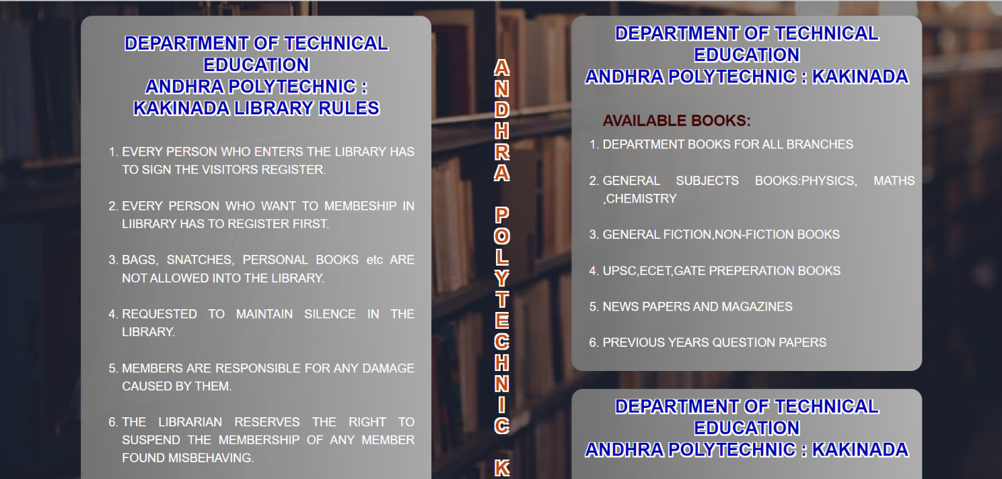

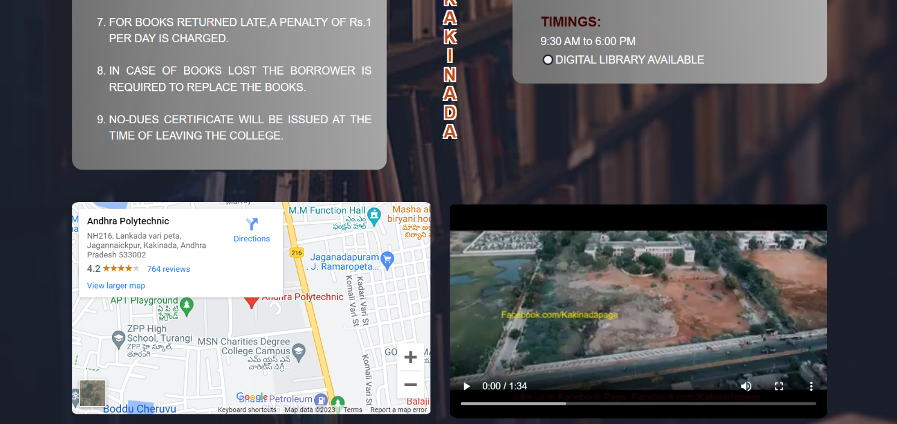

FooterPart:
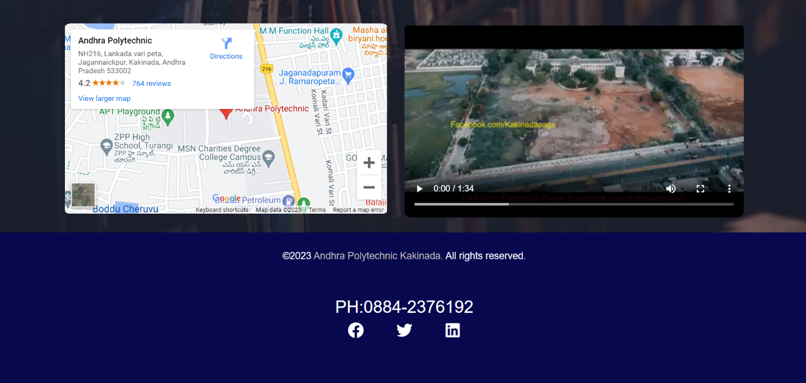

Register page:
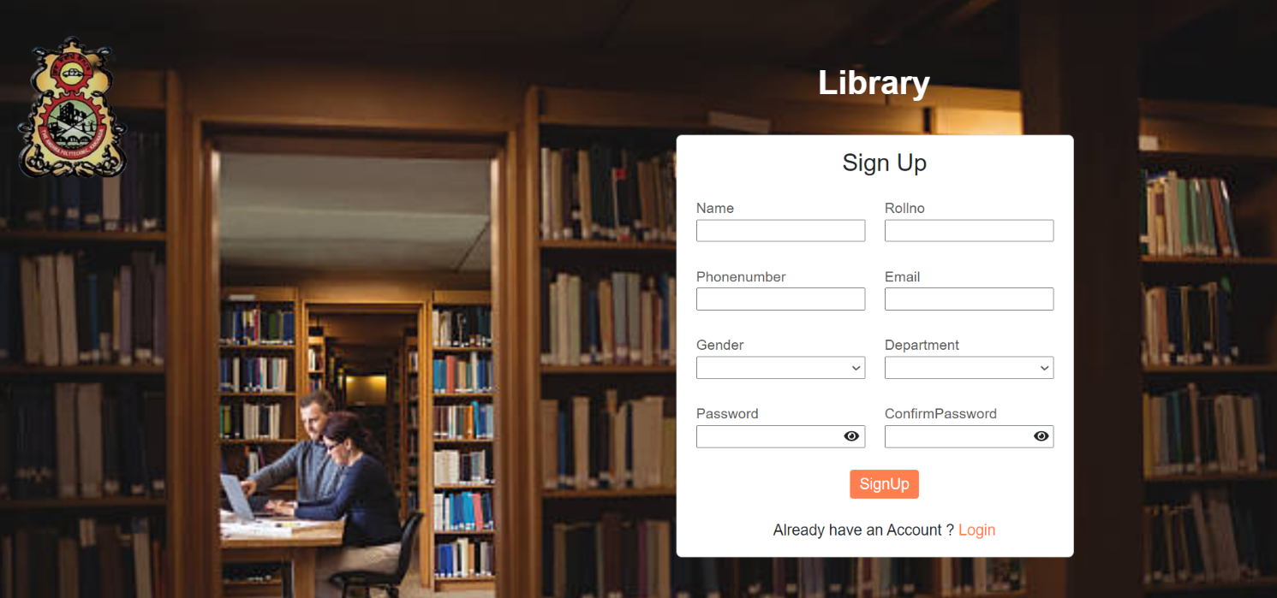

Login:
User Login:


Admin Login:


Forgot password
Otp generate:


Otp Validate:


Reset Password:


Student Books:
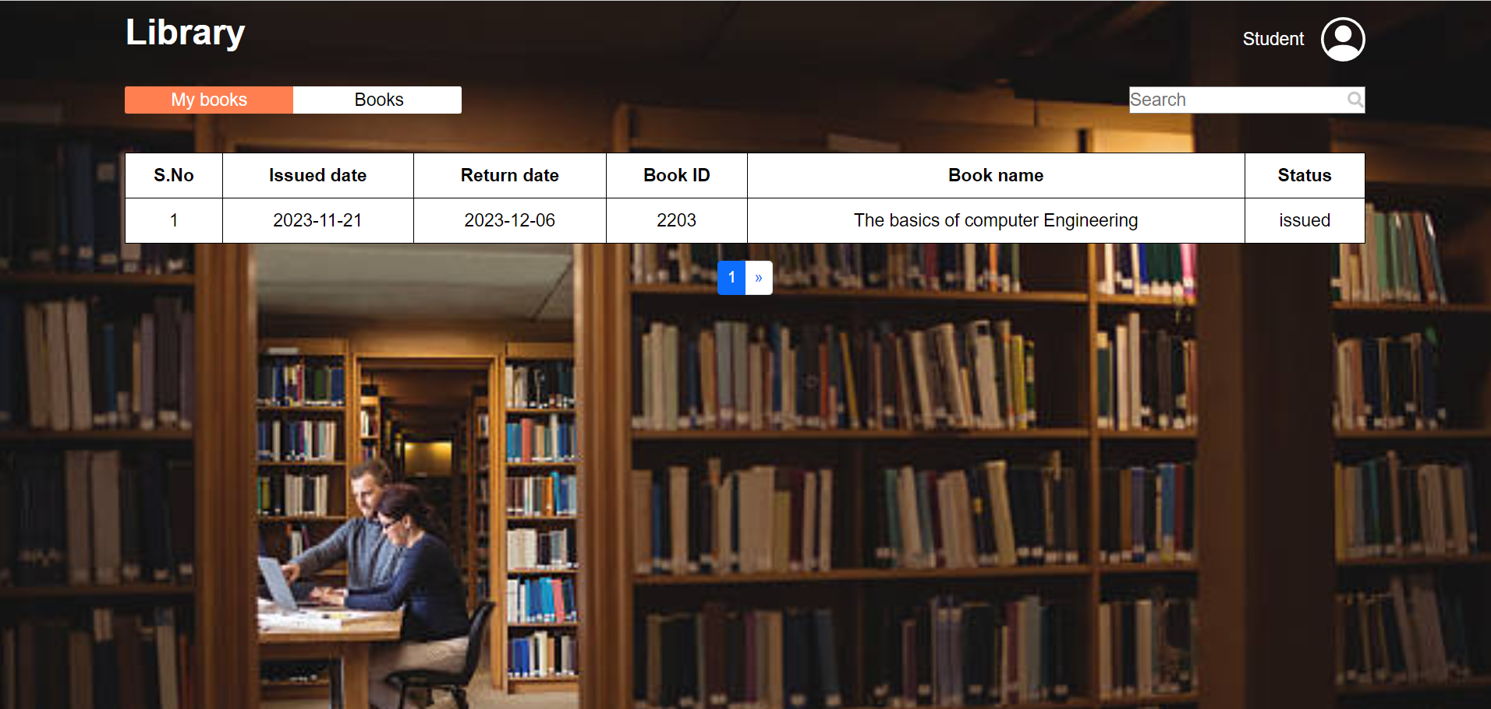

All Books:
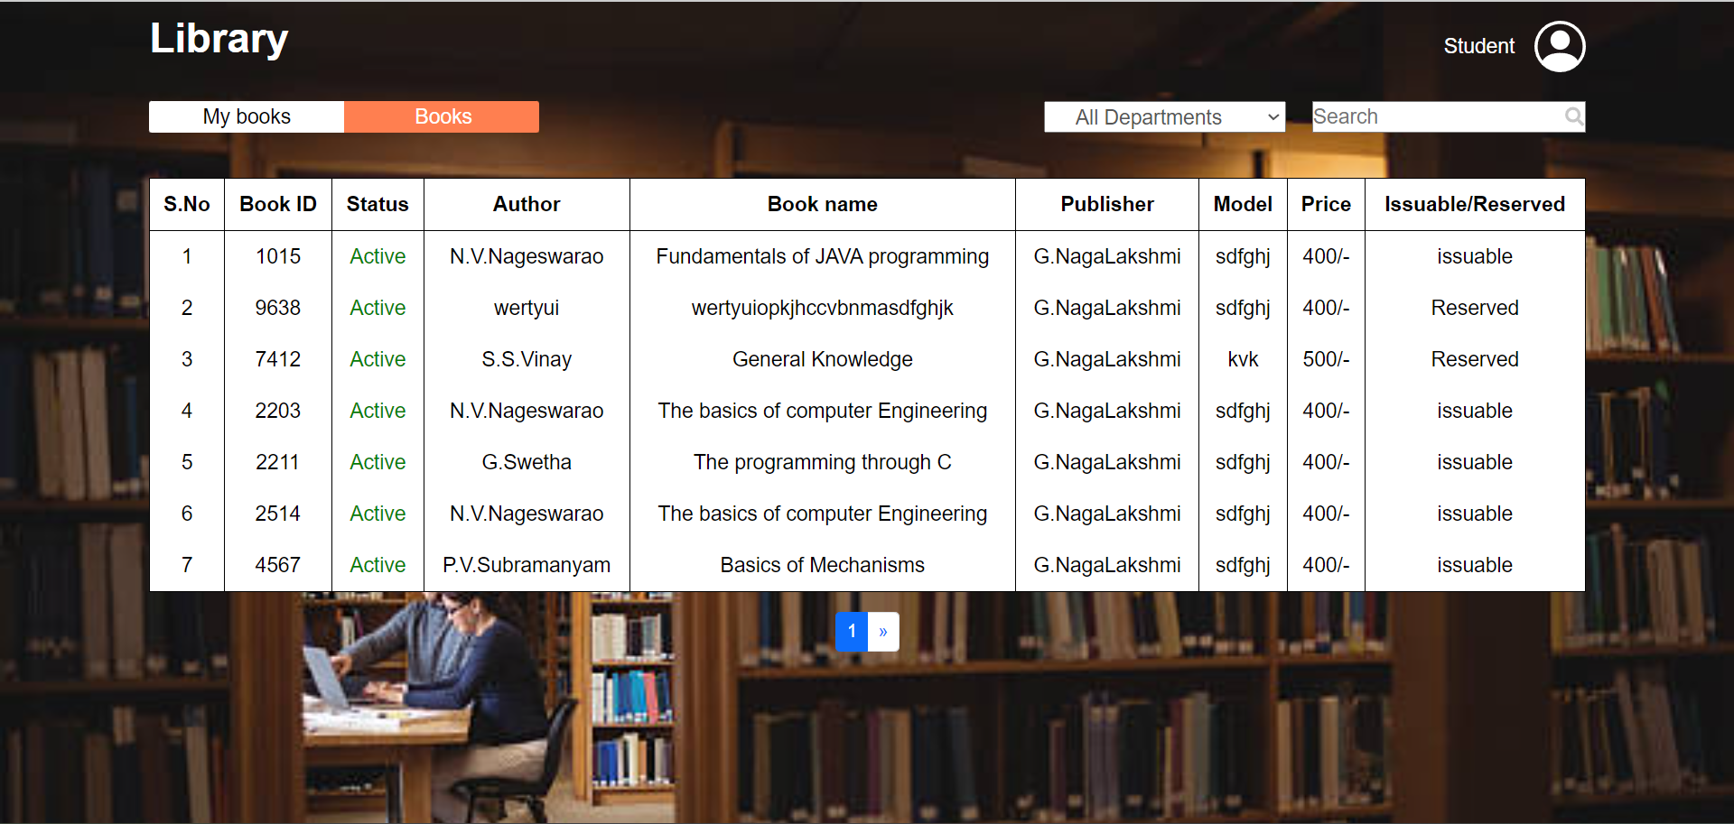

Total Books:
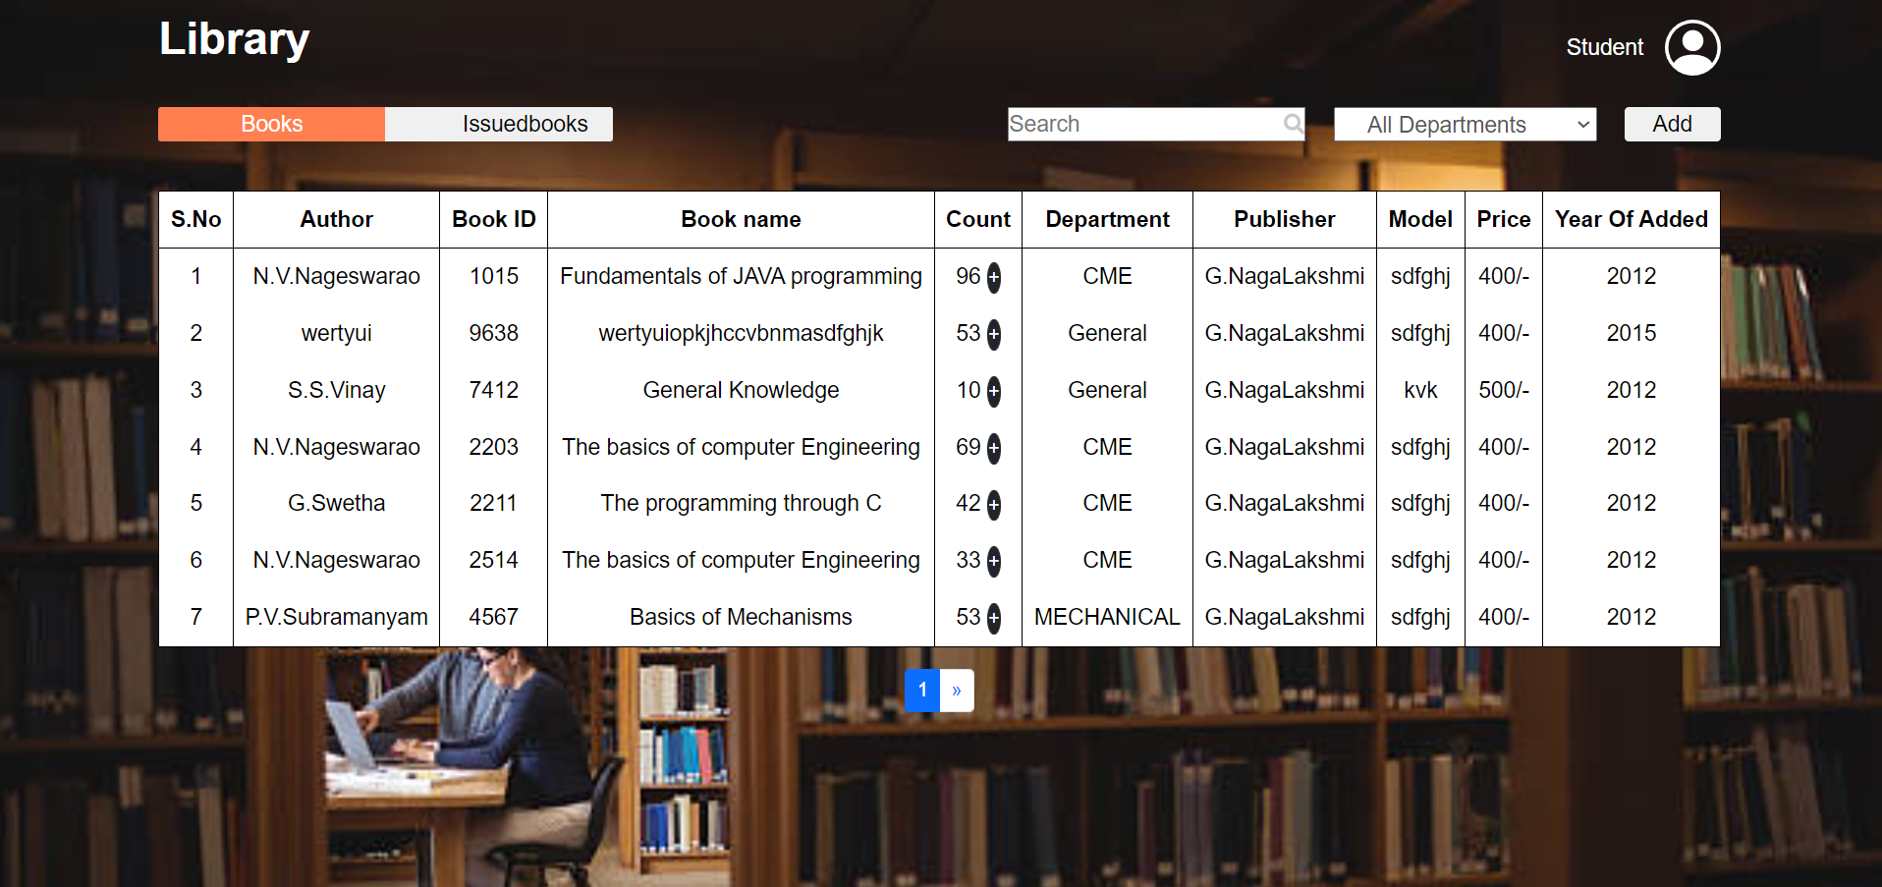
Issued Books:
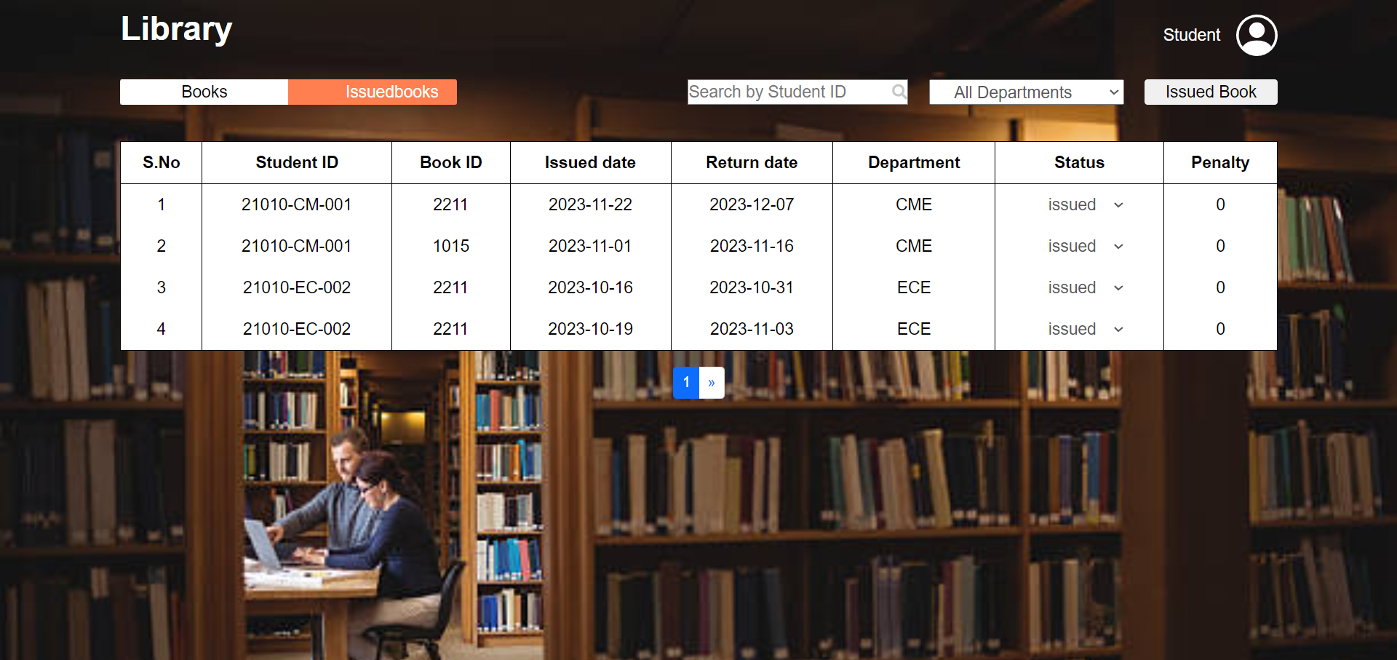

BIBLIOGRAPHY
Introduction:
LMS, an acronym for Library Management System, is a sophisticated software solution designed to transform and modernize traditional library operations.
Objective:
The primary goal of the LMS project is to address challenges and limitations inherent in conventional library systems by introducing a comprehensive digital platform.
Automation Focus:
LMS places a strong emphasis on automation, streamlining key processes like book cataloging, member registration, and book transactions to enhance operational efficiency.

Digital Transition:
The project envisions a transition from manual, paper-based methods to a secure and efficient digital alternative, utilizing contemporary technologies for optimal results.
Technological Foundation:
LMS is built on a technological foundation that includes HTML, CSS, React.js for the front end, and Node.js with the Express framework for the back end.
Database Management:
PostgreSQL, a robust open-source relational database management system, is chosen to handle data storage and retrieval, ensuring data integrity and scalability.
Development Environment:
The development environment is supported by Microsoft Windows 11, and key development tools include Visual Studio Code for coding and PostgreSQL (SQL Shell, PgAdmin) for database management.
User-Friendly Interface:
LMS boasts a user-friendly interface catering to both librarians and patrons, with features such as robust search functionalities and online membership registration.
Integration of RFID/Barcode Technology:
To streamline book transactions, LMS incorporates RFID or barcode technology, minimizing errors and enhancing overall operational efficiency.
Comprehensive Documentation:
The project documentation provides an in-depth exploration of LMS, covering architecture, functionalities, system requirements, and the benefits it offers to library staff and users.

